Physical Organic Mini-Symposium 2026 Abstract Template
S. Smith¹, P. Parker², W. Williams,³ H. Potter⁴
¹Center for Research in Inorganic Chemistry, 1 Research Road, Ridge, NY 11961, USA
²University of Discussions, 400 South Monroe Street, Tallahassee, FL 32399, USA
³Environmental Center for Amazing Chemistry, 1 Yellow Rd., Wichita, KS 67206, USA
⁴Center for Universal Quantum Computation, 2066 Crist Dr., Los Altos, CA 94024, USA
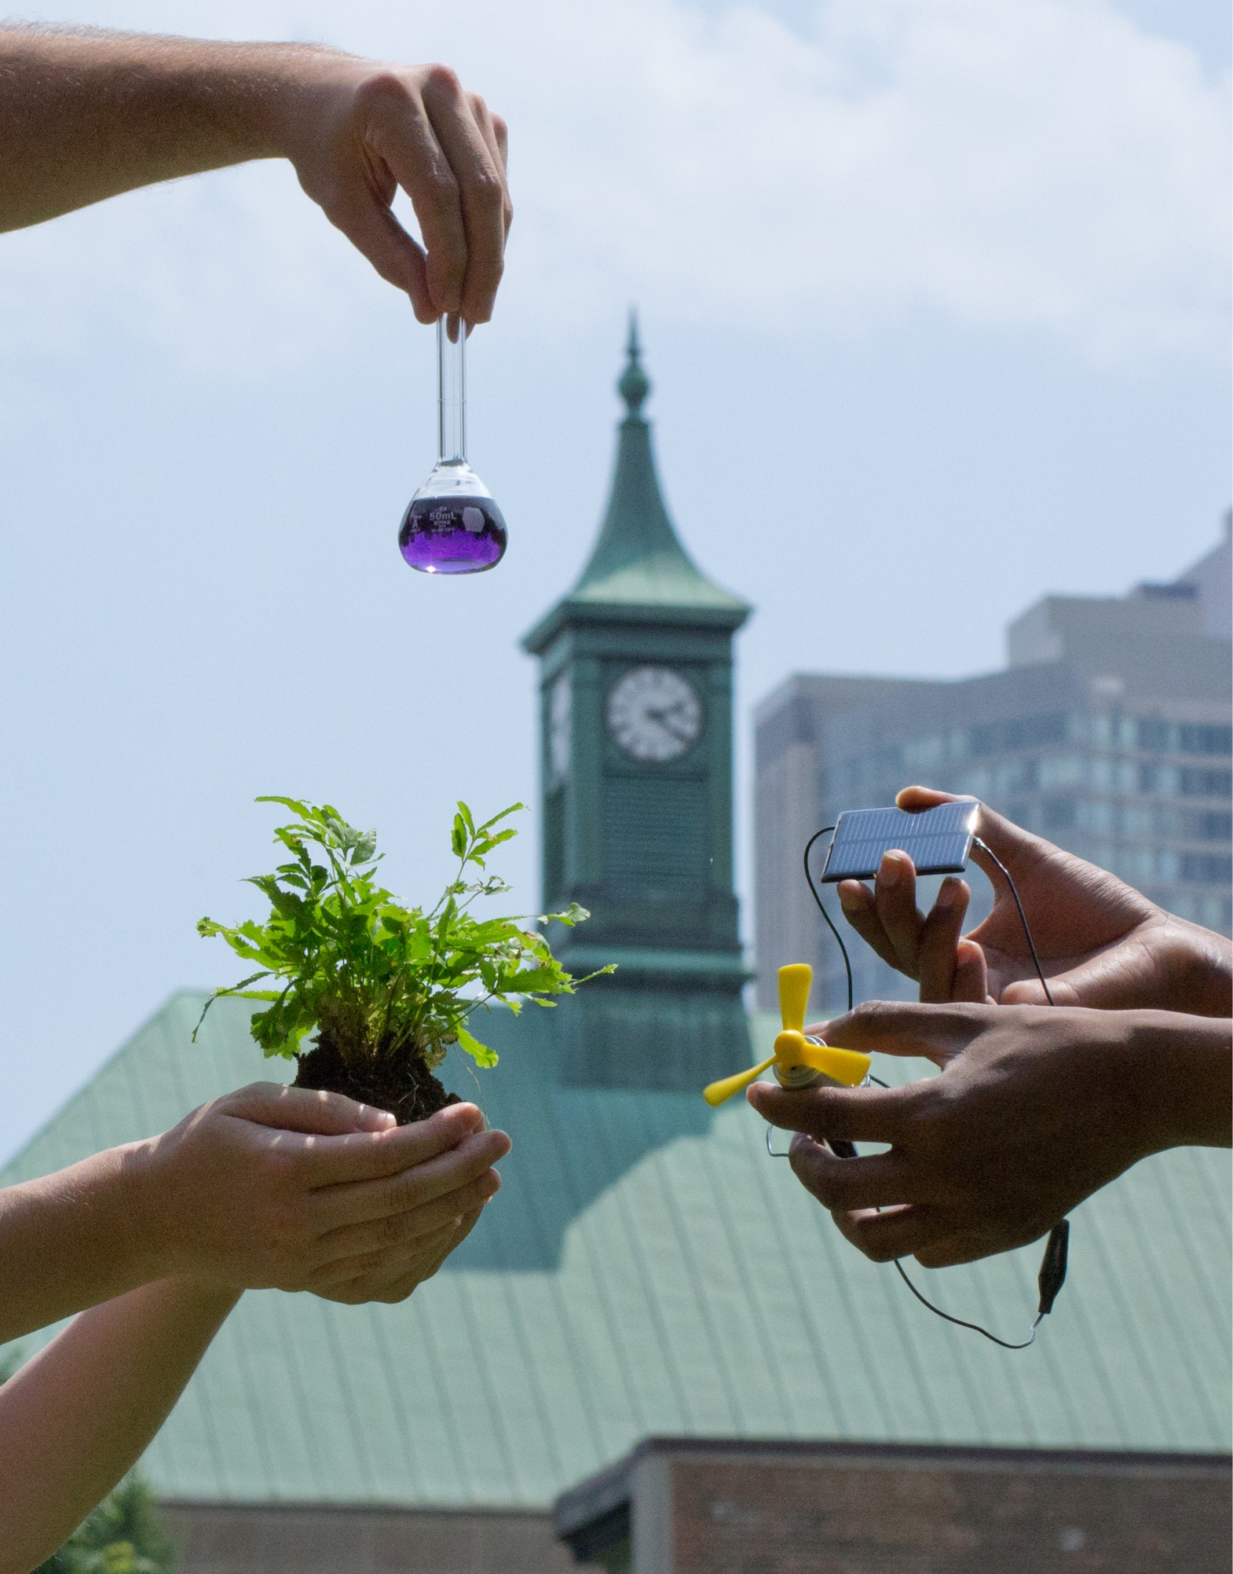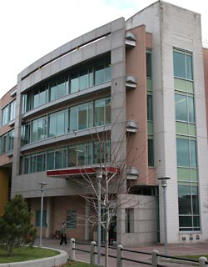
D’Iorio Hall, University of Ottawa, location of the Department of Chemistry [1].

We describe a novel technique for creating abstracts for this conference, which will be shown in this template. This procedure enables researchers to copy and paste their own text into our template and thus have a simple and enjoyable conference registration experience. Importantly, the use of a template gives rise to multi-functional abstracts, which can be employed in understanding each presenter’s research prior to hearing their talk or viewing their poster. We go on to show how coherent text can be essential in the understanding of the research which is going on in the field of physical organic chemistry (which includes – but not limited to - photochemistry, polymer chemistry, materials chemistry, etc), and thus we can promote discussion throughout a wonderful weekend of networking and interaction between colleagues. It is important that the use of references be consistent with this formatting, and that the fonts be identical.[1] We then describe a technique for attaching your abstract; by uploading it to the attached Google Form Linked here: https://forms.gle/orCBRR3tk54zhYXc6 that is part of the registration process.
Fig 1. The iconic clock tower in Kerr Hall at TMU.
Thank you so much for your interest in our conference, we hope that you will join us and help us make POMS 2026 a roaring success here in November at Toronto Metropolitan University (TMU).
This work was supported by large quantities of wonderful organizers. The POMS 2026 website can be found at http://www.torontomu.ca/solar/poms2026.

References:
[1] Smith, S.; Parker, P. Journal of Conference Registration, 2026, 26, 1972-2026.

