Guidance for the Recruitment of Research Participants

Instruction Guide

Before You Begin
- The information provided in parentheses (...) are instructions to guide you as you fill in the document templates.
- The instructions provided in square brackets [...] offer guidance regarding content to be filled in by the researcher to complete these templates.
- Please ensure that you thoroughly remove these parentheses and square brackets as well as the enclosed text and this Instruction Guide page prior to submitting your recruitment materials for REB review.

Important Tips
- Double-check that the information in your recruitment materials matches/match the information provided in your research ethics protocol (and funding proposal if applicable). Recruitment materials should be written at a reading level appropriate for your target audience. Use clear language, avoid acronyms/academic jargon, and explain terms a layperson may not be familiar with to ensure clarity.
- For clarity, consider using second-person pronouns (“you/your”) throughout the form when referring to participants, except on signature pages where you use first-person pronouns (“I”).
- Consider accessibility requirements by consulting TMU’s Understanding Document Accessibility. Consider incorporating universal access symbols.
- If you will be asking participants to complete a screening form or if you have a website landing page with additional information, consider hyperlinking.

Additional Information
- Tri-Council Policy Statement: Ethical Conduct for Research Involving Humans
- TCPS 2 Interpretations
- Guidance in Applying TCPS2
If you have any other questions, please email us at rebchair@torontomu.ca.

List of Elements to Include in the Recruitment Materials
Please use the following list to ensure all required elements are included. Please note that these are not applicable for every type of study, but the corresponding number is included in the poster template below to help guide researchers.
- University and Partner Logos: Display the Toronto Metropolitan University logo prominently in the poster. Include logos of any partner organizations or funders. Ensure logos are clear and large enough to be recognized easily. Maintain proper alignment for a professional look.
- Invitation to Participate: Include a statement that extends an invitation to participate. For example, “You are invited to participate in a research study.”
- Study Title: Provide a short and descriptive title of your study. Ensure the title is concise and captures the essence of your research. It should be informative yet easy to understand.
- Eligibility Criteria: List specific inclusion and/or exclusion criteria such as age range, student status, ethnic/cultural background, etc. Be clear and precise to help potential participants quickly determine their eligibility. Avoid vague criteria.
- Study Description: Briefly describe the purpose of the study in plain language. Keep the description simple and straightforward. Avoid using technical jargon or acronyms that might be unfamiliar to the general public.
- Participant Activities: Explain what participants will be asked to do, such as completing an online survey, participating in an interview, or joining a focus group. Provide a general overview of the activities without going into excessive detail. Ensure that participants understand what will be required of them
- Time Commitment: State the number of sessions and the approximate duration of each session. Be realistic about the time commitment and make sure it is clearly communicated. This helps participants plan accordingly.
- Incentives/Reimbursements: Detail any incentives or reimbursements provided to participants, such as transit tokens or childcare. Clearly outline what participants will receive in appreciation of their time. Make this section straightforward and honest.
- Contact Information and Principal Investigator: Provide contact details for more information, including the contact name, title, department, institutional phone number and email address. If you are a student, mention that this is part of your studies. Use only institutional contact information and avoid personal phone numbers. If the contact information differs from the principal researcher, provide the principal investigator's name. Ensure the principal investigator's information is accurate and clearly listed.
- Ethics Approval: State that your research ethics protocol has been reviewed and approved by the Toronto Metropolitan University Research Ethics Board. Include the REB protocol number (e.g., REB 2024-000). If the study is funded, mention the funder.
Please see the sample poster below as an illustrative example of a recruitment poster.
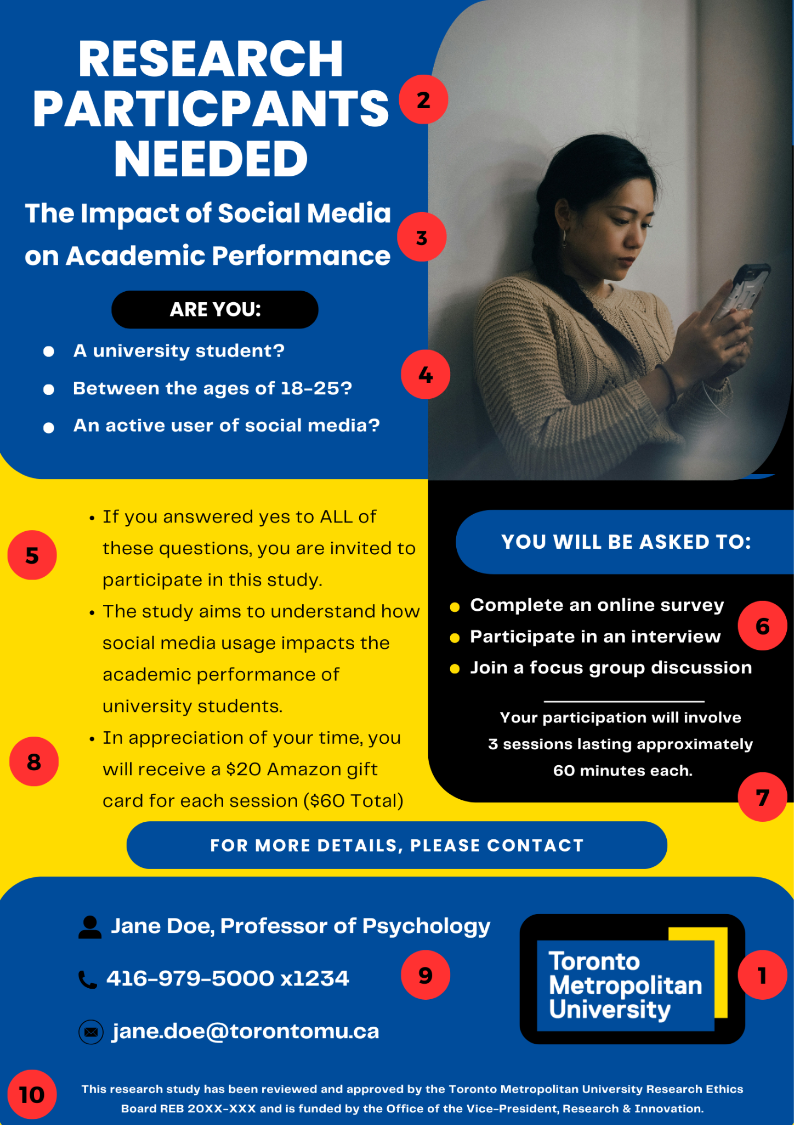

1. Recruitment Poster Template
[Toronto Metropolitan University logo] [Other partner logos]
[Optional heading]
[Title of the study]
Are you:
[Insert specific inclusion and/or exclusion criteria such as age range, student status, ethnic/cultural background, etc.].
If you answered yes to the above-noted questions you may volunteer in this study. The study will [briefly describe the purpose of the study in plain language].
You will be asked to [insert a general description of all the activities the participant will be engaging in, e.g., complete an online survey, participate in an interview, join a focus group, etc.].
Your participation will involve [number] session(s) lasting approximately [time per session] minutes [each].
In appreciation of your time, you will receive [insert any incentive being provided and/or reimbursement for costs to the participant, e.g., transit tokens, childcare, etc.].
If you are interested in participating in this study or would like more information, please contact:
[Contact name and title – if you are a student, mention this is part of your studies]. [Contact department].
416-979-5000 [x0000] (Note to researcher: Do not use personal phone numbers.)
Email: [Institutional email address]
(If the contact information above differs from the principal researcher, please insert): The primary researcher of this study is [insert PIs name].
This research study has been reviewed and approved by the Toronto Metropolitan University Research Ethics Board [REB protocol number i.e. 20YY-XXX] and is funded by [Funder, if the project is funded].

2. Phone/In-Person Script/Outline
Hello, my name is [name]. I am a [student/researcher/research assistant] at Toronto Metropolitan University in the [Department/School]. May I speak with [participant’s name]?

When the participant comes to the phone:
I am reaching out to you to see if you might be interested in participating in a research study [Title]. We are interested in learning/exploring [purpose of the research].
To participate you need to be [eligibility criteria]. You would participate in a [survey, interview, focus group, experiment] that will take approximately [number of minutes/hours] for which you will [receive money, gift card, be entered into a draw for X amount or prize]. The study will take place [by phone, in which lab, location, online survey software, online video conferencing platform].

If you are interested in participating (include all options available to potential participants):
- (If screening over the phone): Do you have a few minutes to answer a few questions to determine if you’re eligible?
  - (If yes): [Insert screening questions].
  - (If no): Is there a better time to call for a brief 10-minute conversation.
- (If you are not screening over the phone, explain how participants can contact the research team or how they can participate):
  - Email me at [email address] or call me at [extension/phone number]
  - Go to this link (link to online survey/Google Form)
  - Scan this QR code (for in-person recruitment)
  - Can you please share your email so we can send you a copy of the consent form?
I would like to thank you in advance for your time and consideration. Do you have any further questions?
(If no):
Thank them for their time. If you have any further questions, please contact me at [give contact information].

3. Social Media Posts

Version 1
(Most suitable for platforms where longer posts are the norm.)
Research Volunteers Needed
[Name(s) of researchers] from the [Program, Department, Faculty] at Toronto Metropolitan University are looking for volunteers who [inclusion and exclusion criteria from Section 13 of the application].
The study is looking at [very brief, 1-2 sentence summary of topic]. It involves a [survey, interview, focus group, experiment] that will take place [on campus, online, in name of community] and will involve approximately [number of minutes/hours] of your time.
[If linking directly to an online survey/experiment. Remember that the link should be inserted in the actual text of the post as links are not clickable in a photo.]
If you are interested in learning more or participating, please click [the link for the survey or screening form or google form/consent].
For the full details of the study, please [click this link to complete the screening form OR contact the researchers].
The ethics protocol for this study has been reviewed and approved by the Toronto Metropolitan REB [REB 20XX-XXX].

Version 2
(For platforms with shorter content or limitations on post length.)
(Note to researcher: This version is meant to guide potential participants to a more detailed recruitment ad and should always be used in connection with a longer linked ad or provide a link to a website, screening form, online survey.)
TMU researchers are looking for [students, staff, individuals, immigrants, etc.] to take part in a [online survey, interview, in-person research study, etc.] on [topic]. Please visit [link to online information about study that will include further information as per the templates above and/or consent for online survey] for more information.

4. Recruitment Email Template
Hello,
My name is [name]. I am a [student, researcher, research assistant] at Toronto Metropolitan University in the [Department/School, etc.]. I am contacting you to see if you might be interested in participating in a research study.
If you are a student, include the following sentence: This research is being done as part of my [Master’s/PhD] project and my supervisor’s name is [name and title].
The focus of the research is [general purpose of the research].
We are looking to recruit [include eligibility criteria, e.g., undergraduate students who are 17-29].
If you agree to volunteer you will be asked to [e.g., complete an X-minute online survey, participate in a one-hour interview, participate in a two-hour focus group, etc.]
In appreciation of your time, you will receive [insert any incentive being provided and/or reimbursement for costs to the participant, e.g., presto tickets, childcare, etc.]
The research is funded by [name of funder] and has been reviewed and approved by the Toronto Metropolitan University Research Ethics Board.
If you are interested in more information about the study [please read the attached Letter of Information OR click on this link to the Letter of Information] or would like to volunteer, please reply to this email or call [416-979-5000 x0000].

5. Request to Distribute Recruitment Materials
Email subject line: [Study Title]
Salutation paragraph: Dear [name of the primary contact at the organization/agency],
Introductory paragraph: My name is [your name]. I am a [your position/role/title] at Toronto Metropolitan University and am conducting research on [your research topic].
For student/graduate researchers: …under the supervision of [name], as part of my Master’s/PhD program in [name] at the department of [name].
Request paragraph: I am writing to request your assistance in circulating the appended recruitment materials for my study to [specify eligibility criteria] by [indicate how they should circulate the materials, e.g., share the appended email via your mailing list].
[A paragraph outlining details about the study (number of participants required, what participation involves, study location, time commitment, incentives, etc.) can be optionally added here to provide context to the organization/agency].
(Optional): Should you have suggestions about any changes that the recruitment materials or process might benefit from, please let us know so we can assess them and submit a request for approval to the Toronto Metropolitan University’s Research Ethics Board.
Thanks in advance for your assistance. If you have any questions or suggestions, please feel free to contact:
[Student/Faculty PI name] [Faculty supervisor (for student PIs) name]
[Contact information] [Contact information]
The ethics protocol for this study has been reviewed and approved by the Toronto Metropolitan University REB (REB 20XX-XXX).

