Slide 1 - Welcome
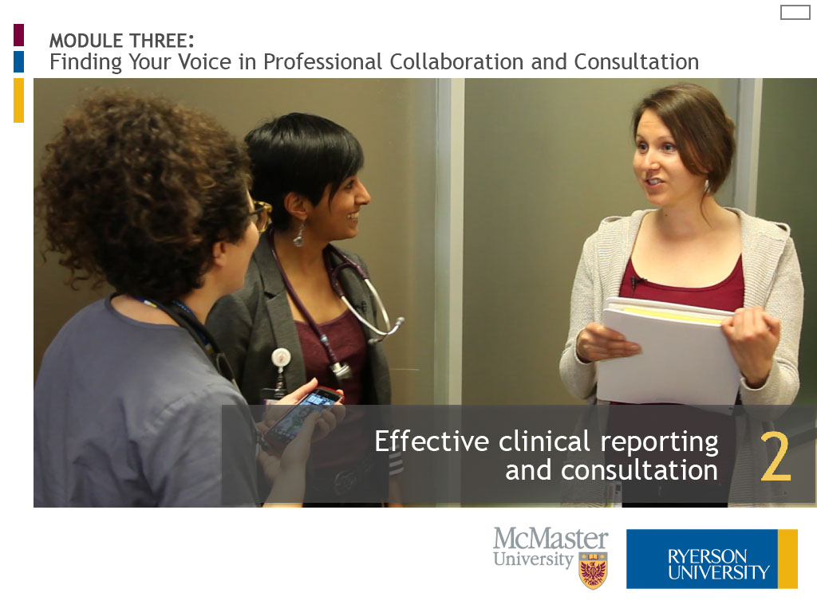
Slide notes
Hello. My name is Elizabeth Allemang and I am an Associate Professor in the Midwifery Education Program at Ryerson University.
Welcome to “Effective Clinical Reporting and Consultation,” the second lesson of three in the learning module “Finding Your Voice in Professional Collaboration and Consultation.”
Let's begin.
Text Captions

MODULE THREE:
Finding Your Voice in Professional Collaboration and Consultation

Effective clinical reporting
and consultation

Slide 2 - Please enter your name
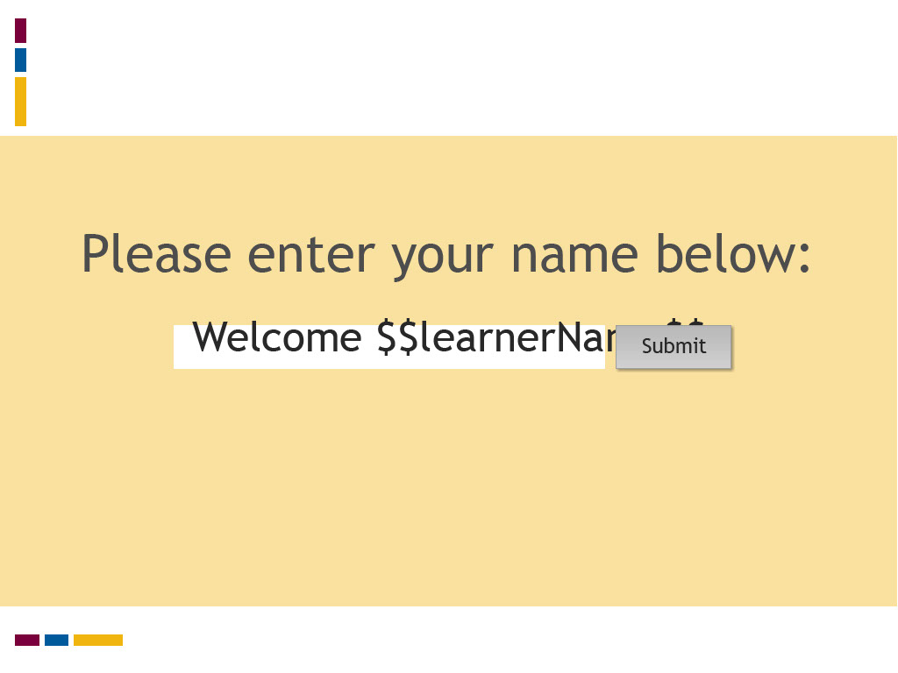
Slide notes
Text Captions

Please enter your name below:

Welcome

Slide 3 - Introduction
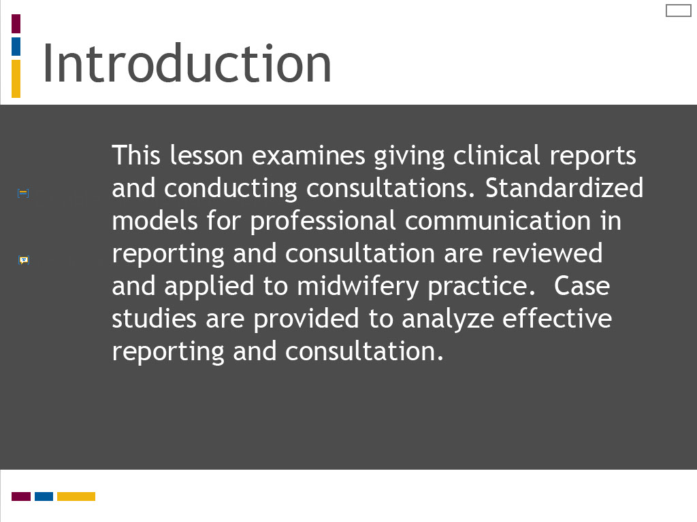
Slide notes
This lesson examines the skills of giving clinical reports and conducting consultations.
Standardized models for professional communication in reporting and consultation are reviewed and applied to midwifery practice.
Case studies are provided to analyze effective approaches for reporting and consultation.
Text Captions

Introduction

This lesson examines giving clinical reports and conducting consultations. Standardized models for professional communication in reporting and consultation are reviewed and applied to midwifery practice. Case studies are provided to analyze effective reporting and consultation.

Slide 4 - Learning Outcomes
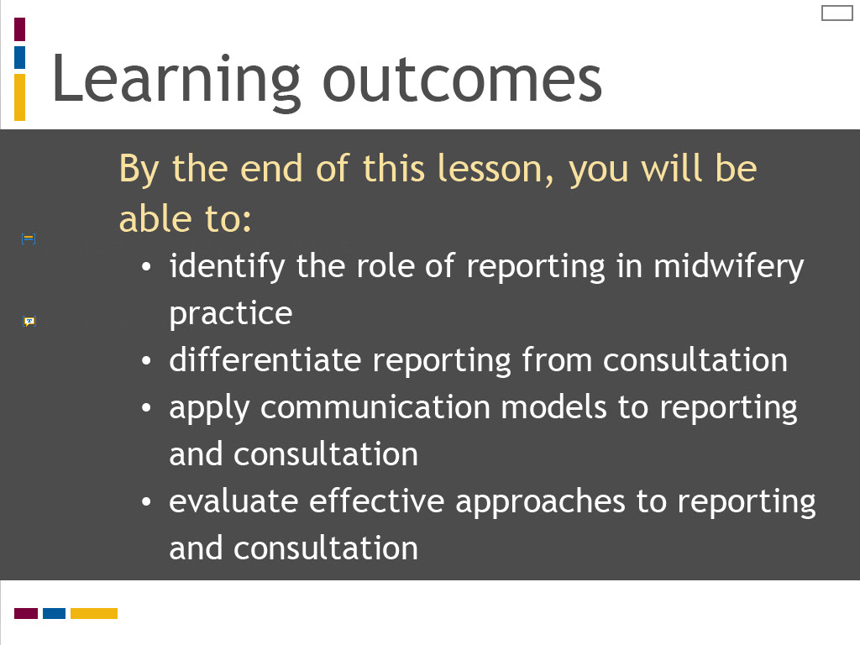
Slide notes
The learning outcomes for this lesson are summarized on this screen. Take a moment to review these before proceeding.
Text Captions

Learning outcomes

By the end of this lesson, you will be able to:
- identify the role of reporting in midwifery practice
- differentiate reporting from consultation
- apply communication models to reporting and consultation
- evaluate effective approaches to reporting and consultation

Slide 5 - Reporting vs consulting
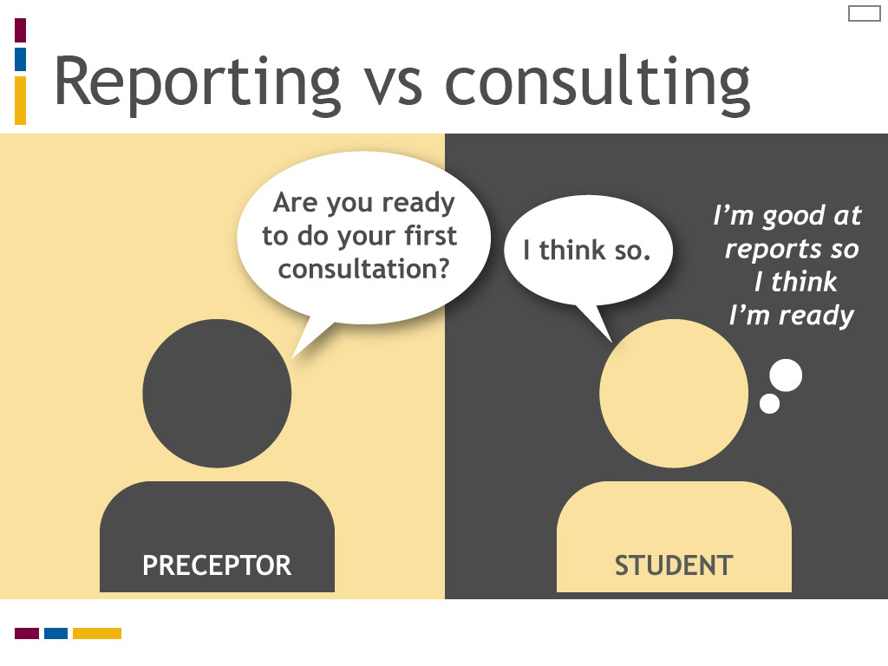
Slide notes
Giving clinical reports to another care provider and conducting consultations are two central forms of professional collaboration and communication in midwifery practice.
While reporting and consultation both represent formal interactions for sharing information about client care, they play different roles in clinical practice.
We will review their similarities and differences, and examine approaches for effective reporting and consultation.
Text Captions

Reporting vs consulting

Preceptor asks student “Are you ready to do your first consultation?” Student replies “I think so,” and thinks to self “I’m good at reports, so I think I’m ready.”

Slide 6 - Communication models
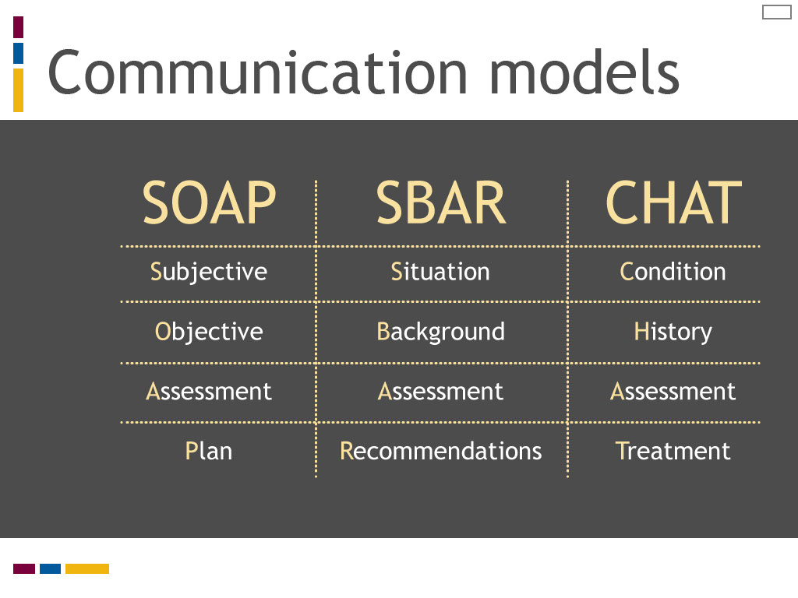
Slide notes
You were introduced to the SOAP, CHAT and SBAR models as decision making tools in the second lesson of Module Two.
These models were developed as communication tools and were later adapted as clinical reasoning tools in health care education and practice.
Review the meanings for each model summarized on this screen.
As you may recall, the SOAP model was developed by an American physician in the 1960s as a tool to standardize documentation in the patient record.
We expanded the SOAP model to ASOAPER to integrate the steps of anticipate, evaluate and reformulate.
SBAR was developed by the American military and aviation industries to standardize communication to improve safety,
and it was later adopted by the health care industry as tool to improve communication at the point of handover.
SBAR is typically expressed as iSBAR to include “identify yourself” in the clinical reporting process.
CHAT was developed by Salus Global for the Managing Obstetrical Risk Efficiently, or MOREOB, program for Canadian maternity care providers as a communication tool for consultation.
You may observe any of these models in clinical practice. In this lesson, we explore an expanded CHAT model integrating the step of identify.
You will learn how to use this expanded model for giving clinical reports and conducting consultations.
You will also reflect on the role of a clinical reasoning tool, such as ASOAPER, to improve effective consultation.
(Please refer to the second lesson of Module Two if you would like to review these models in decision making and understand the expanded ASOAPER model.)
Text Captions

Communication models

Table with SOAP, SBAR and CHAT models listed side-by-side.
SOAP - Subject, Objective, Assessment, Plan
SBAR - Situation, Background, Assessment, Recommendations
CHAT - Condition, History, Assessment, Treatment
Slide 7 - Communication models
Slide notes
You were introduced to the SOAP, CHAT and SBAR models as decision making tools in the second lesson of Module Two.
These models were developed as communication tools and were later adapted as clinical reasoning tools in health care education and practice.
Review the meanings for each model summarized on this screen.
As you may recall, the SOAP model was developed by an American physician in the 1960s as a tool to standardize documentation in the patient record.
We expanded the SOAP model to ASOAPER to integrate the steps of anticipate, evaluate and reformulate.
SBAR was developed by the American military and aviation industries to standardize communication to improve safety,
and it was later adopted by the health care industry as tool to improve communication at the point of handover.
SBAR is typically expressed as iSBAR to include “identify yourself” in the clinical reporting process.
CHAT was developed by Salus Global for the Managing Obstetrical Risk Efficiently, or MOREOB, program for Canadian maternity care providers as a communication tool for consultation.
You may observe any of these models in clinical practice. In this lesson, we explore an expanded CHAT model integrating the step of identify.
You will learn how to use this expanded model for giving clinical reports and conducting consultations.
You will also reflect on the role of a clinical reasoning tool, such as ASOAPER, to improve effective consultation.
(Please refer to the second lesson of Module Two if you would like to review these models in decision making and understand the expanded ASOAPER model.)
Text Captions

Communication models

Table with SOAP, SBAR and CHAT models listed side-by-side.
SOAP - Subject, Objective, Assessment, Plan
SBAR - Situation, Background, Assessment, Recommendations
CHAT - Condition, History, Assessment, Treatment
Slide 8 - Effective clinical reporting
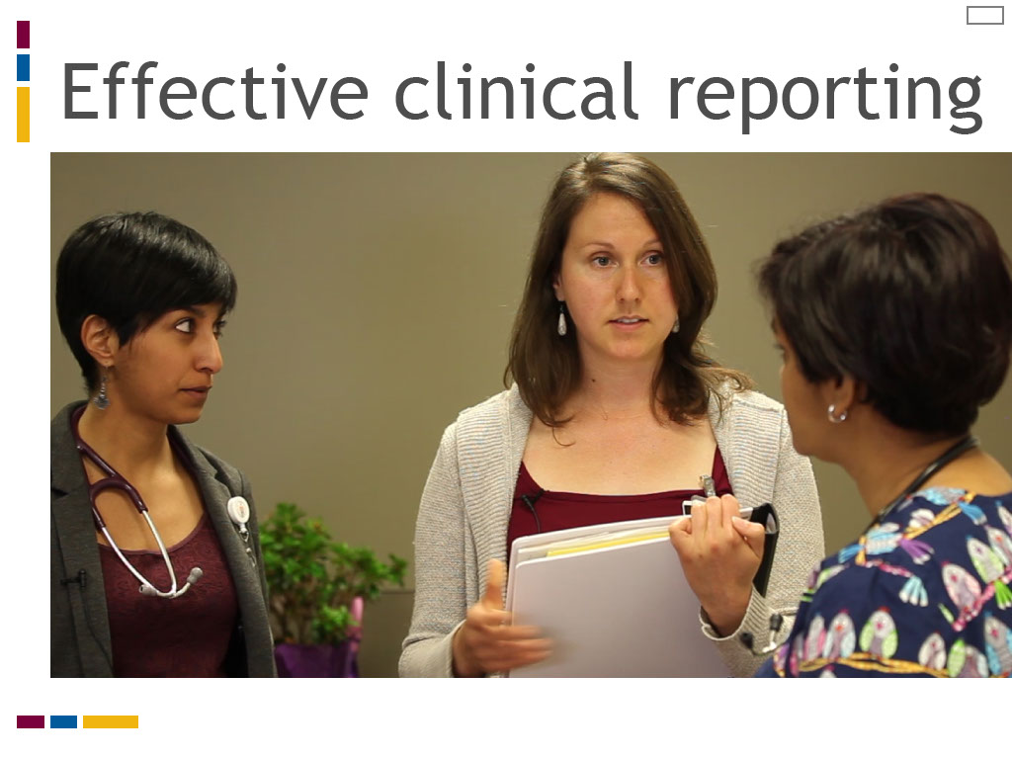
Slide notes
Clinical reporting is used to share information about client or patient care among members of the health care team.
Reports may be used when care is shared by multiple care providers, or when care is handed over from one provider to another.
Clinical reporting also supports continuity of care for the client or patient.
This meaning of reporting is distinct from the report of a clinical condition provided by one care provider to another at the point of consultation.
Midwives and student midwives use clinical reporting to communicate with other midwives and midwifery students,
as well as to communicate with interprofessional care providers.
Text Captions

Effective clinical reporting

Slide 9 - Giving reports
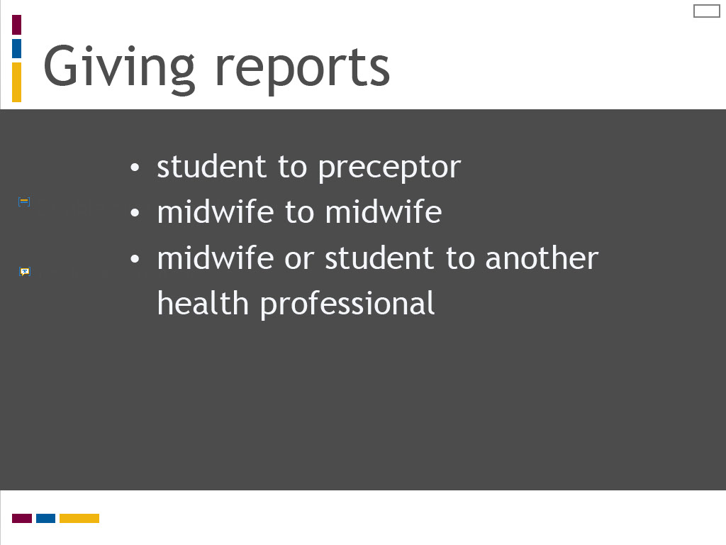
Slide notes
Midwifery students often first participate in professional communication by “giving report” to their preceptor.
Midwives sharing care of a client report to one another when handing over or sharing care.
A primary midwife gives a formal report to a second midwife, for example, when the second is called and/or arrives at a birth.
Midwives working in shared call models also use formal reporting when handing over care for rotating call.
Midwives report to other health professionals when collaborating or handing over care, such as with a paramedic or a postpartum nurse.
Reflect on a situation where you observed or participated in clinical reporting.
Who were the players and how was the clinical information reported?
Because clinical reporting is a formal professional interaction, there are principles and safety considerations to keep in mind.
Standardized communication models can also facilitate effective communication in reporting, as well as the learning of this skill.
Text Captions

Giving reports

- student to preceptor
- midwife to midwife
- midwife or student to another health professional

Slide 10 - Key principles of reporting
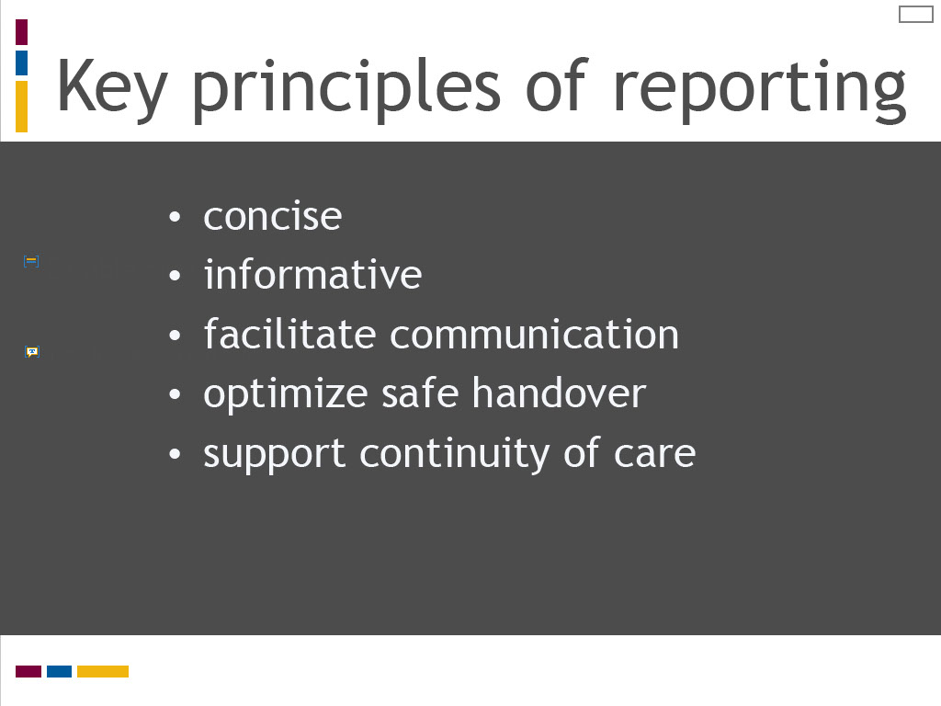
Slide notes
Review the principles for clinical reporting summarized on this screen.
Giving concise, informative reports improves team work by ensuring the appropriate information is communicated with providers sharing client care.
Finding the right balance of information can be challenging.
You don’t want to provide so much information that the priority details are lost in translation.
At the same time, you want to provide enough information so that the other provider has the information they need to provide effective care.
Consider the situation of calling a second midwife to a birth.
The second midwife needs to understand the history of the labour to transition seamlessly into the client’s care,
provide appropriate support to the primary midwife, and assume primary care responsibility for the newborn.
Reporting is an equally important step when handing over clinical responsibility from one care provider to another, such as handing over care for sleep relief.
Effective reporting also facilitates continuity of care for the client by the health care team.
Learning how to provide concise, informative reports is an art and a life long learning skill. This skill can be learned and refined.
You may want to develop sample scripts for typical reports and rehearse them with another student or with your preceptor.
You could also record yourself giving a report to your preceptor or another health professional,
and assess how your report strikes an appropriate balance of being concise yet informative.
Another helpful strategy for learning how to give reports is to exaggerate "errors” in reporting.
You can do this by giving a report for the same situation in three ways:
too little information, too much information, and an appropriate balance of information.
Simulated opportunities for giving report using this framework and the iCHAT tool are provided in the next lesson of this module.
Text Captions

Key principles of reporting

- concise
- informative
- facilitate communication
- optimize safe handover
- support continuity of care

Slide 11 - Safety considerations
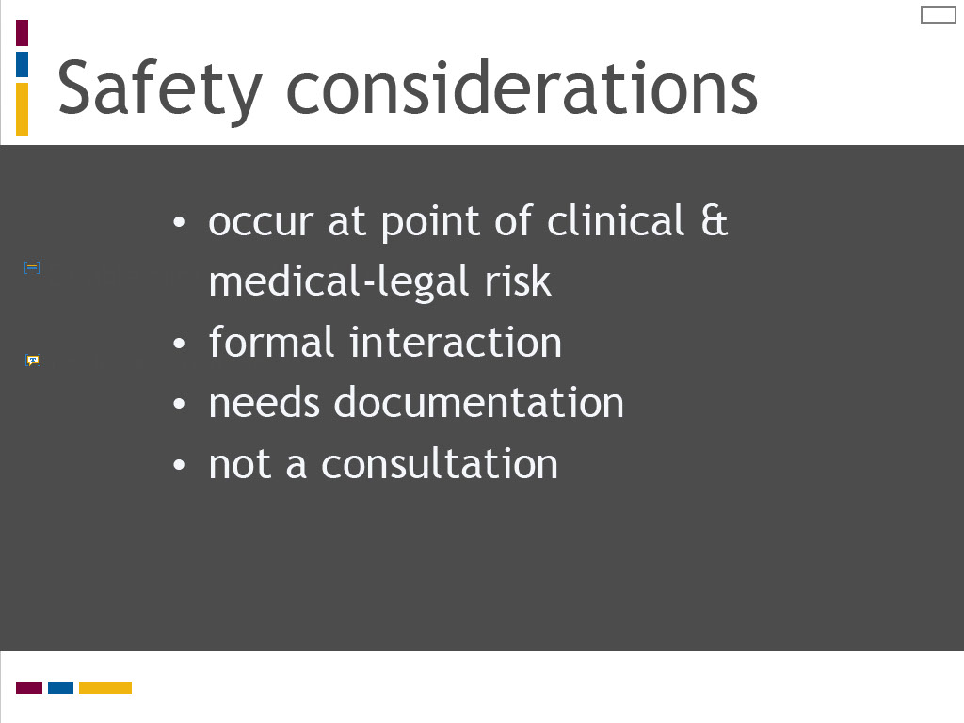
Slide notes
Reports play an important role in improving safety of care and reducing medico-legal risk.
Reporting typically occurs at transition points in care that are vulnerable to errors in transfer of information.
Effective reporting facilitates the formal sharing of the right information with the right people.
It is important to be aware what reports are and what they are not, both clinically and for medico-legal reasons.
A clinical report, like a consultation, is a formal professional interaction that requires documentation.
A report resembles a consultation, but the two are not equivalent.
Reports ask others to take actions, such as implementing a treatment plan or following a clinical order,
whereas consultations seek expert advice or recommendations for a treatment plan.
As we reviewed in Lesson 1 of this module, the midwifery consultation process is defined in professional standards with distinct indications and communication responsibilities.
Text Captions

Safety considerations

- occur at point of clinical & medical-legal risk
- formal interaction
- needs documentation
- not a consultation

Slide 12 - iCHAT for reporting
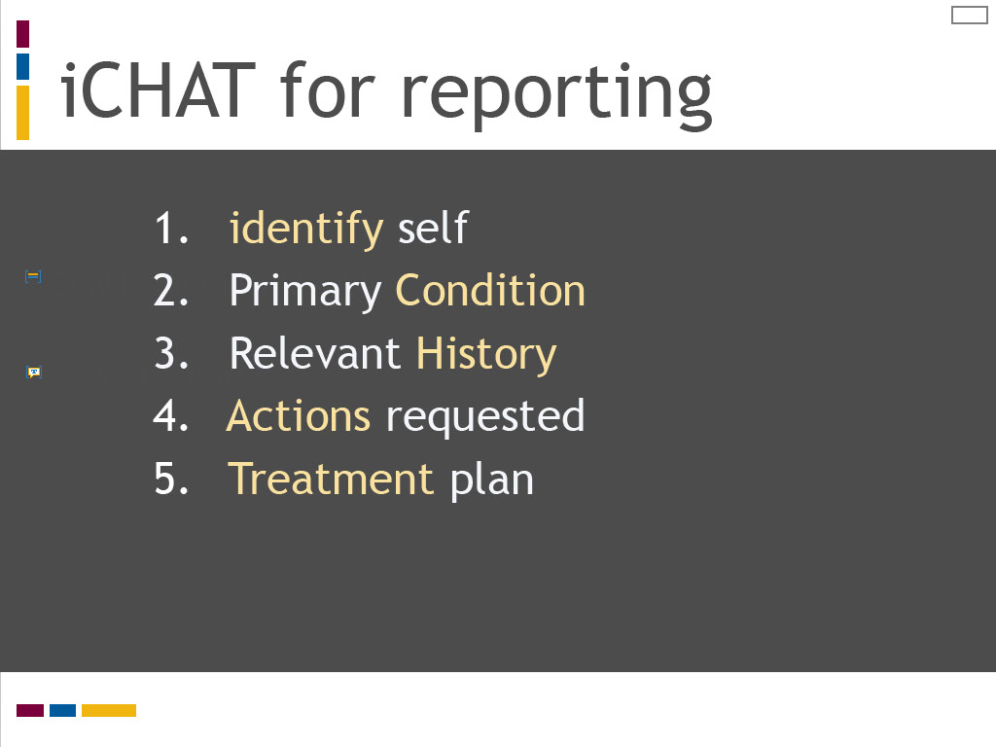
Slide notes
A modified version of the CHAT communication model for giving a clinical report is listed on this screen.
The “i” for “identify” is typically listed in lowercase to symbolize its addition to the conventional CHAT model.
Identifying yourself is the first step in giving a report.
This would include stating your name and your position as a student midwife.
You are expected to include the name and position of your preceptor as a Registered Midwife.
The second step is to give a concise statement of the client’s condition, including any relevant history.
You next provide a clear statement for any actions you would like the other provider to implement.
Finally, you state your treatment plan, including any client preferences.
When reporting to your preceptor, this final step may look different, especially as a beginning student.
At first, you are often reporting actions you have taken and/or are planning, along with your tentative treatment plan for review and input by your preceptor.
As you take increasing responsibility to lead care, you may use this final to request your preceptor take an action.
Text Captions

iCHAT for reporting

- identify self
- Primary Condition
- Relevant History
- Actions requested
- Treatment plan

Slide 13 - Using iCHAT for reporting
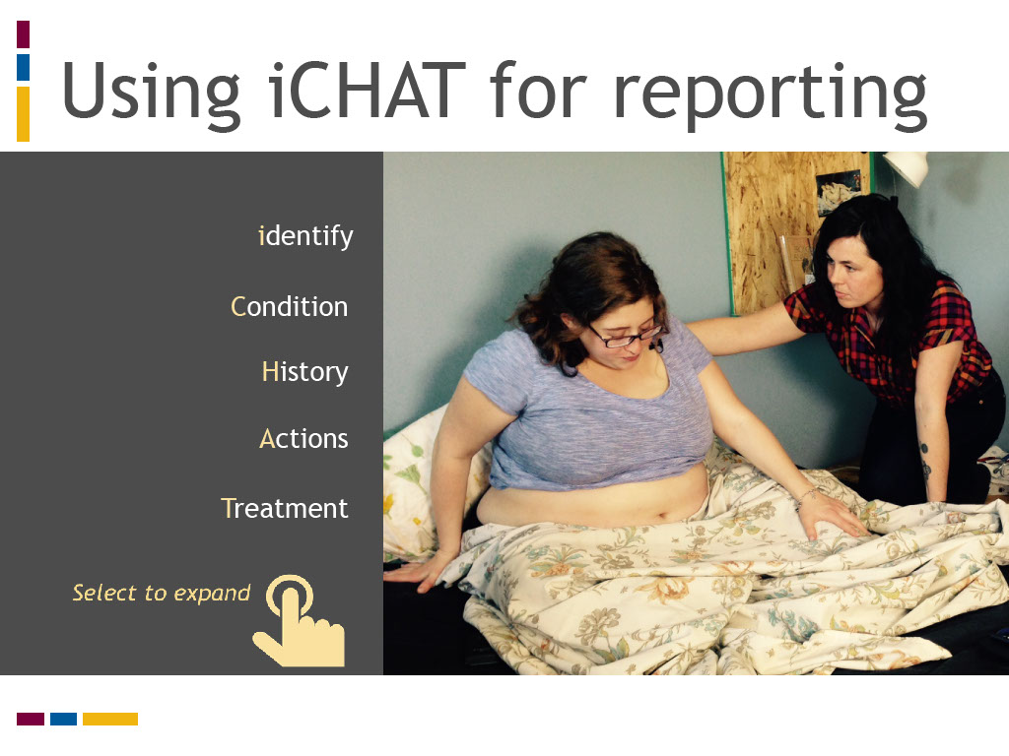
Slide notes
To review an iCHAT handover report from a student midwife to a postpartum nurse for a client staying in hospital following a postpartum hemorrhage,

select each step in the iCHAT model listed on this screen.
Text Captions

Using iCHAT for reporting

- Identify
  - I am Sally S, student midwife working with Registered Midwife Rachel B.
- Condition
  - Naomi is a healthy primiparous client who gave birth vaginally 3 hours ago. The perineum is intact. She had a 750 mL PPH resolved with IV oxytocin. She is stable now.
- History
  - Naomi’s hemoglobin was 120 g/L prior to birth. I sent a postpartum CBC to the lab. Naomi was catheterized for 100 mL of urine immediately after the birth. She has been up to void once.
- Actions
  - Please provide routine care and review the hemoglobin results when they are available. Contact me by pager if the hemoglobin is below 100 g/L or with any other concerns. Discontinue IV fluids once the bag has run through.
- Treatment
  - I have recommended Naomi stay overnight for observation. The plan is for discharge tomorrow if all observations are normal. I will follow up in the community for regular postpartum visits.

Slide 14 - Effective consultation
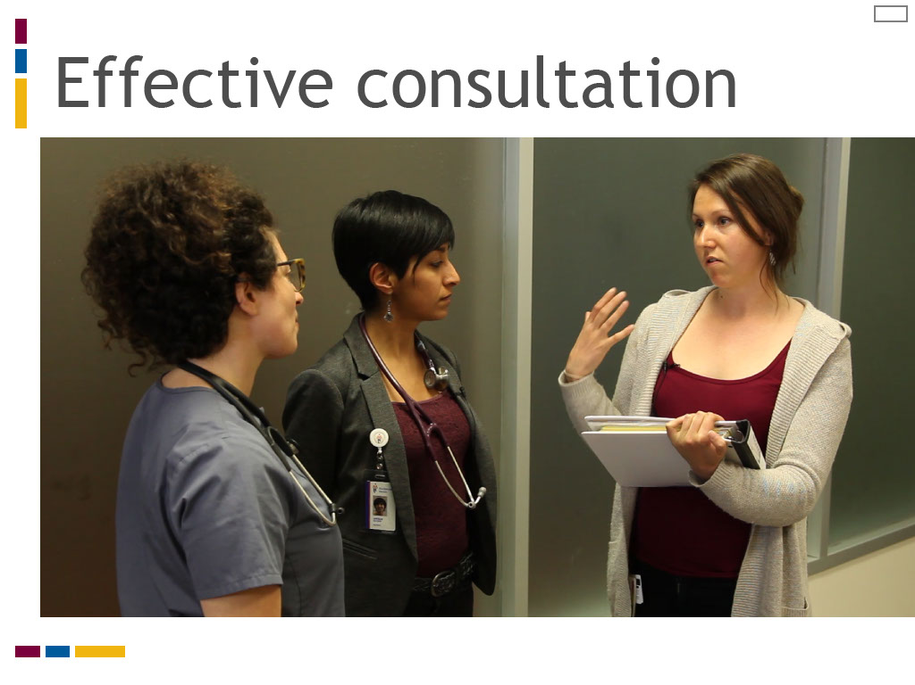
Slide notes
Effective consultation, like reporting, is linked to formal professional communication.
It also benefits from the use of a standardized communication tool, as well as the use of a clear process.
The College of Midwives of Ontario standard on consultation and transfer of care defines the process for consultation,
clinical indications, and the role and responsibilities of the midwife.
The use of a systematic method for clinical reasoning to determine a likely diagnosis also helps the midwife or student midwife to identify the need for consultation.
Text Captions

Effective consultation

Slide 15 - What makes consultation effective?

Slide notes
We will now examine what makes consultation effective.
Before proceeding, reflect on the question shown on this screen.
From your understanding of the consultation process from the previous lesson, try to identify 5 factors that make consultation effective.
Text Captions

What makes consultation effective?

Slide 16 - Key principles for effective consultation
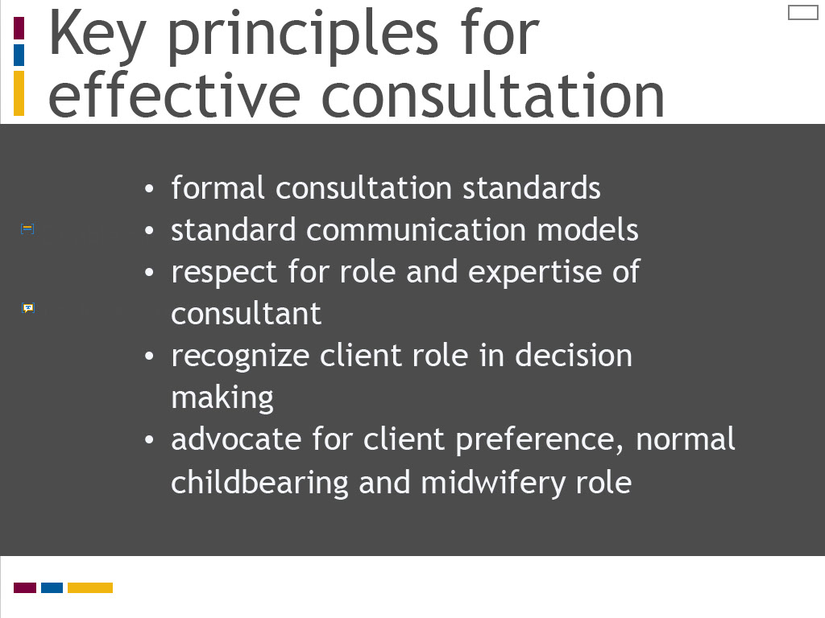
Slide notes
Formal consultation standards help to standardize and define the consultation process for providers and recipients of care.
Communication models, like iCHAT, provide a common framework to exchange clinical information between health professionals involved in the consultation process.
These models facilitate concise and clear communication by prompting the care provider seeking consultation to cluster and present clinical information using an organized structure.
Respect for the role, expertise, and responsibilities of all players involved in the consultation process also facilitates effective professional interactions, as well as safe and effective care for the client or patient.
In midwifery consultation, it is also appropriate to advocate for client preference and for approaches that promote normal childbearing.
It is also appropriate to suggest a treatment plan that integrates midwifery care to its widest scope under regulation.
Text Captions

Key principles for effective consultation

- formal consultation standards
- standard communication models
- respect for role and expertise of consultant
- recognize client role in decision making
- advocate for client preference, normal childbearing and midwifery role

Slide 17 - iCHAT for consultation
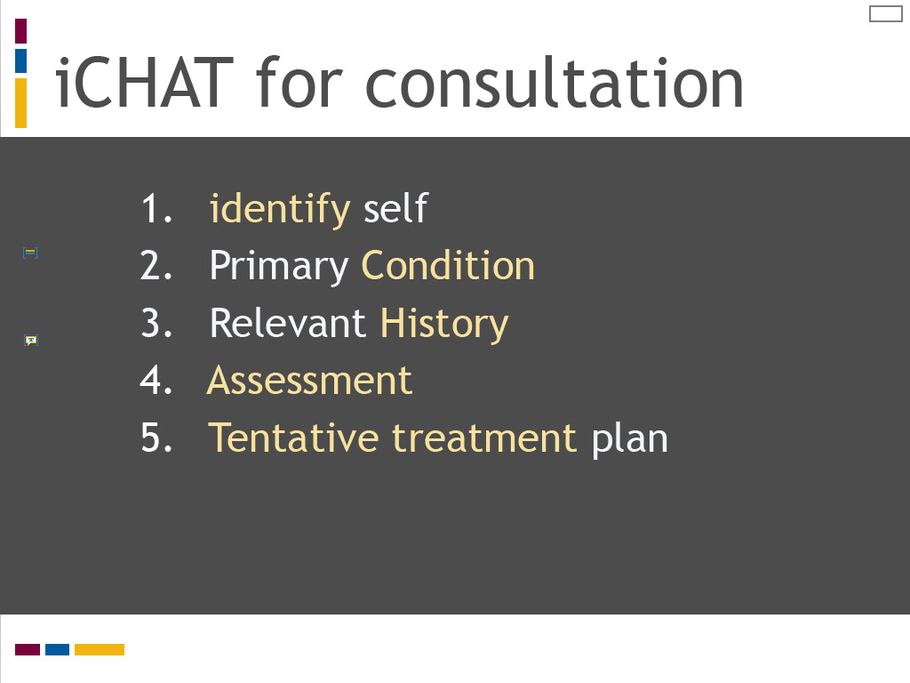
Slide notes
Recall the iCHAT model was developed as a communication tool for consultation.
The meaning of its steps in consultation are summarized on this screen.
Take a moment to review these carefully and compare each one to the iCHAT reporting model.
Can you spot and explain any differences?
“Identify” is again added as a standard first step for communication in consultation.
The primary difference when using iCHAT for consultation is the meaning of “A.”
In this model, “A” refers to communication of the consulting provider’s assessment or analysis for a likely diagnosis, rather than a request for an action.
The “T” also takes on different meaning in the consultation process.
It is commonly represented as “tentative” treatment plan to recognize the consultant’s role to provide advice or recommendations for a final treatment plan.
A tentative treatment plan would include any plan considerations by the care provider requesting consultation and any relevant client preferences.
The consultant provides advice or recommendations that confirm or modify the tentative treatment plan.
Text Captions

iCHAT for consultation

- identify self
- Primary Condition
- Relevant History
- Assessment
- Tentative treatment plan

Slide 18 - Effective consultation
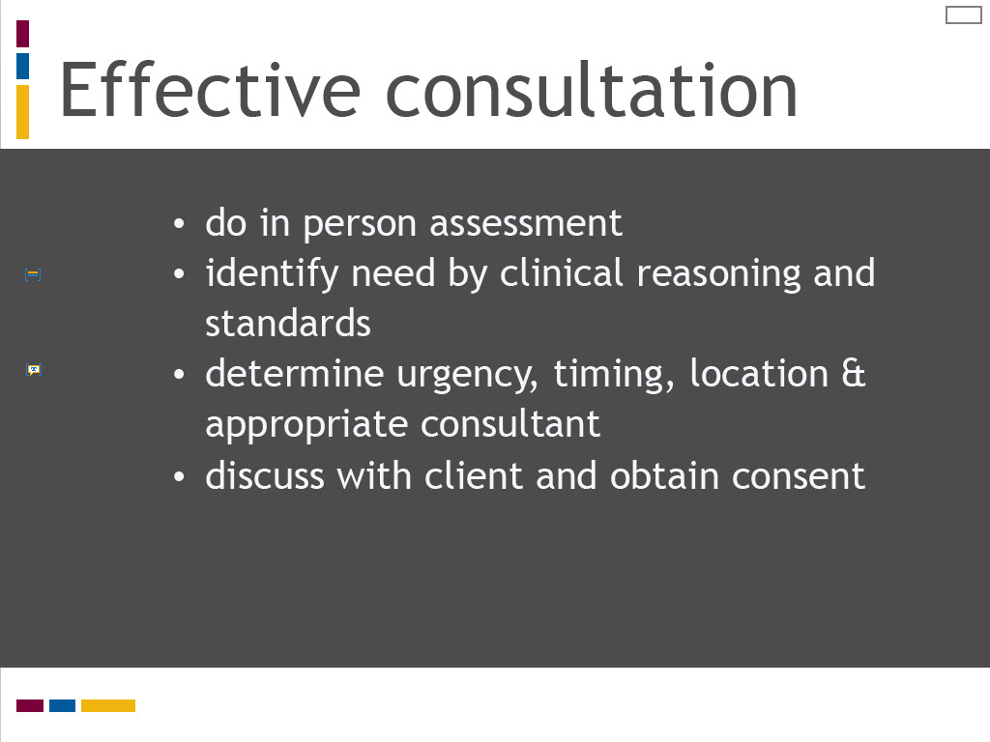
Slide notes
Steps for effective consultation in midwifery practice are listed on this screen and the following one.
They reflect the consultation process as outlined in the CMO Consultation and Transfer of Care standard.
An important first step in the consultation process is for the primary care provider to conduct an in person assessment or evaluation of the client’s condition prior to initiating consultation.
This step should be practiced routinely, except in urgent situations requiring emergency care or where other factors impact timely assessment, such as geographic distance or inclement weather.
This step allows the primary care provider to determine the need for consultation by diagnostic reasoning and practice standards, or for other reasons such as client request.
Factors such as the level urgency, the timing and location for the consultation, and the appropriate consultant need to be determined.
The consultation plan is then discussed with the client and consent obtained.
Text Captions

Effective consultation

- do in person assessment
- identify need by clinical reasoning and standards
- determine urgency, timing, location & appropriate consultant
- discuss with client and obtain consent

Slide 19 - Effective consultation
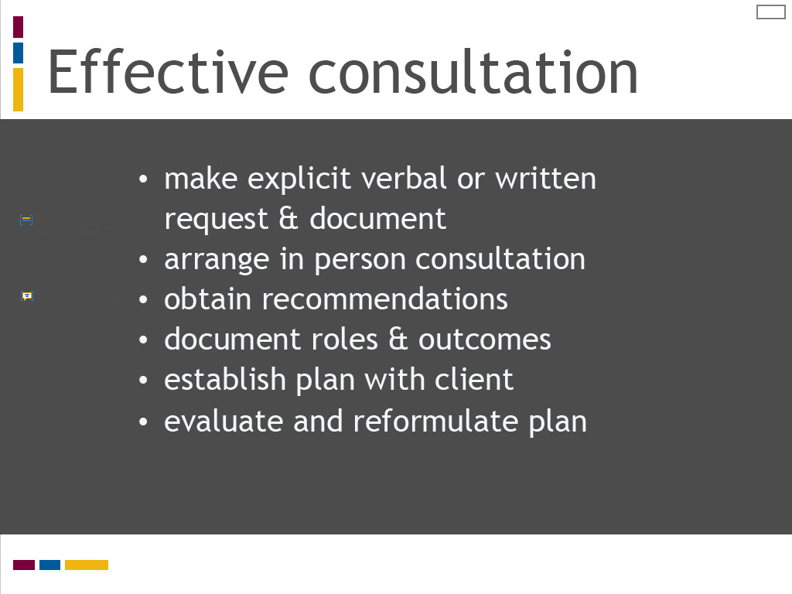
Slide notes
The steps that follow on this screen should be familiar to you from our review of the midwifery consultation process in Lesson 1.
Review these carefully. An important step for optimizing effectiveness in consultation is for the request to be made explicitly.
It is the midwife’s responsibility to know and explain their professional standards, rather than expect consultants to know these.
It is the midwife’s role to arrange an in person assessment of the client by the consultant.
The midwife needs to clearly understand the consultant’s recommendations.
These should be reported directly, rather than interpreted by the client.
It is the midwife’s responsibility to document roles and outcomes following the consultation, and review these with the client to develop a plan of care.
The consultation process is not over once the plan is made.
Like the clinical reasoning process we examined in Module Two, the midwife is responsible to continue to evaluate the care plan and reformulate the plan as needed.
Text Captions

Effective consultation

- make explicit verbal or written request & document
- arrange in person consultation
- obtain recommendations
- document roles & outcomes
- establish plan with client
- evaluate and reformulate plan

Slide 20 - Case Study I: Effective consultation
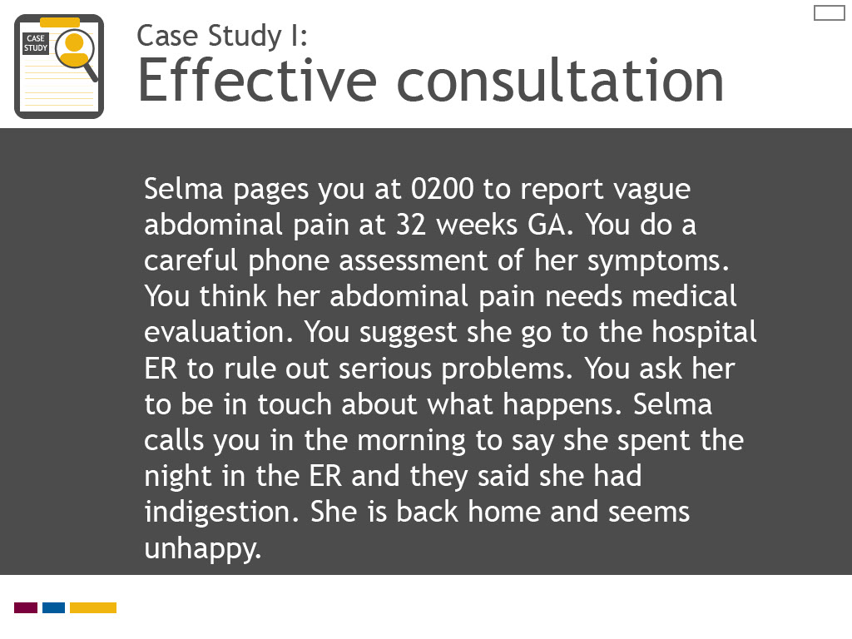
Slide notes
Review the case scenario listed on this screen.
Reflect on the effectiveness of your consultation process as the midwife in this case.
You will be asked to list factors for why this consultation is not effective. Identify as many as you can.
You will also be asked to reflect on how the consultation process could be improved.
You can then compare your answer to a correct response.
Keep the CTC standard and the iCHAT and ASOAPER models in mind to guide your analysis of the decision making and consultation in this case.
Text Captions

Selma pages you at 0200 to report vague abdominal pain at 32 weeks GA. You do a careful phone assessment of her symptoms. You think her abdominal pain needs medical evaluation. You suggest she go to the hospital ER to rule out serious problems. You ask her to be in touch about what happens. Selma calls you in the morning to say she spent the night in the ER and they said she had indigestion. She is back home and seems unhappy.
.

Case Study I:
Effective consultation

Slide 21 - Case study 1: Effective consultation
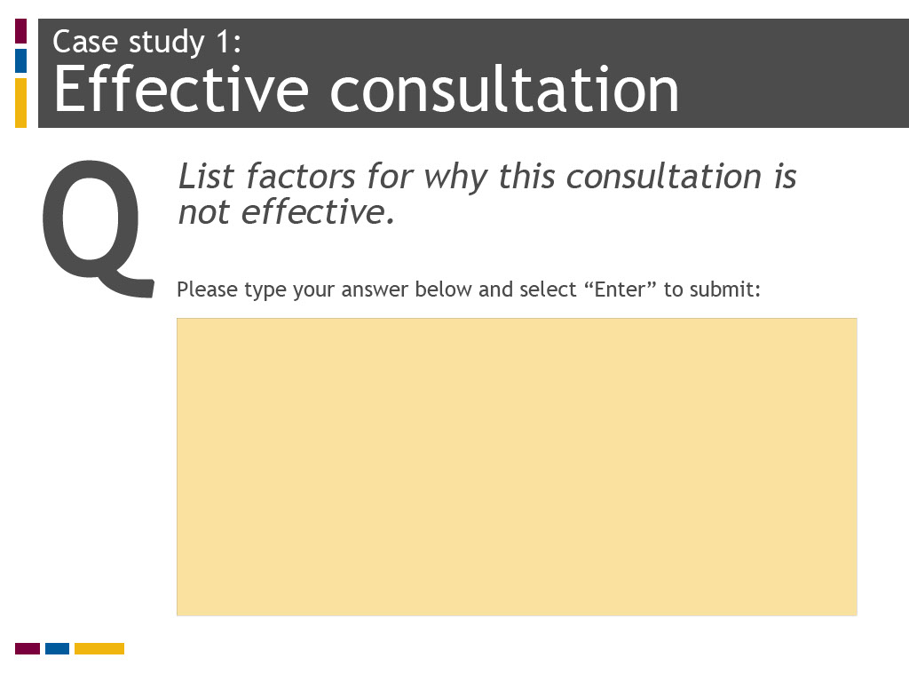
Slide notes
Text Captions

Case study 1:
Effective consultation

List factors for why this consultation is not effective.

Slide 22 - Case study 1 Answer
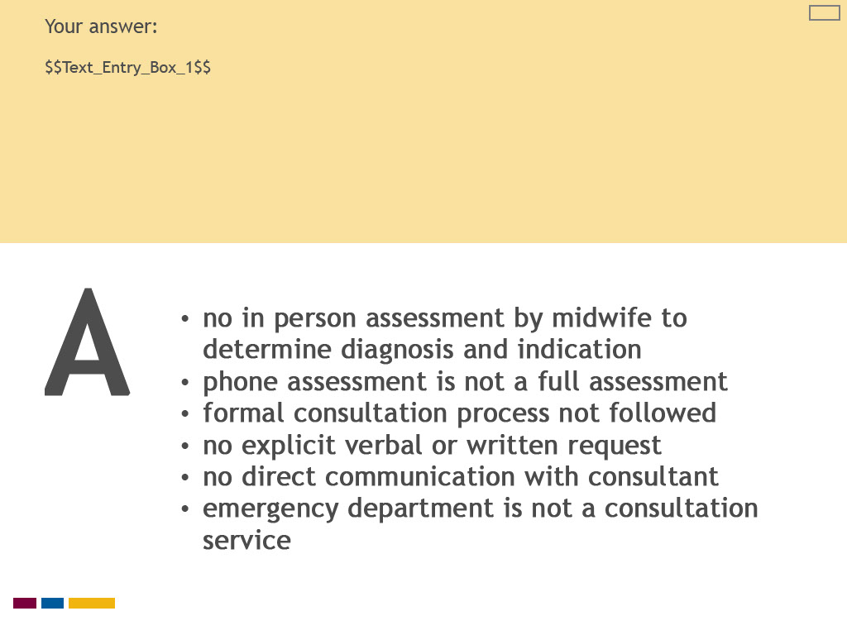
Slide notes
Text Captions

A

Your answer:

no in person assessment by midwife to determine diagnosis and indication
phone assessment is not a full assessment
formal consultation process not followed
no explicit verbal or written request
no direct communication with consultant
emergency department is not a consultation service

Slide 23 - Case study 1: What is transfer of care?
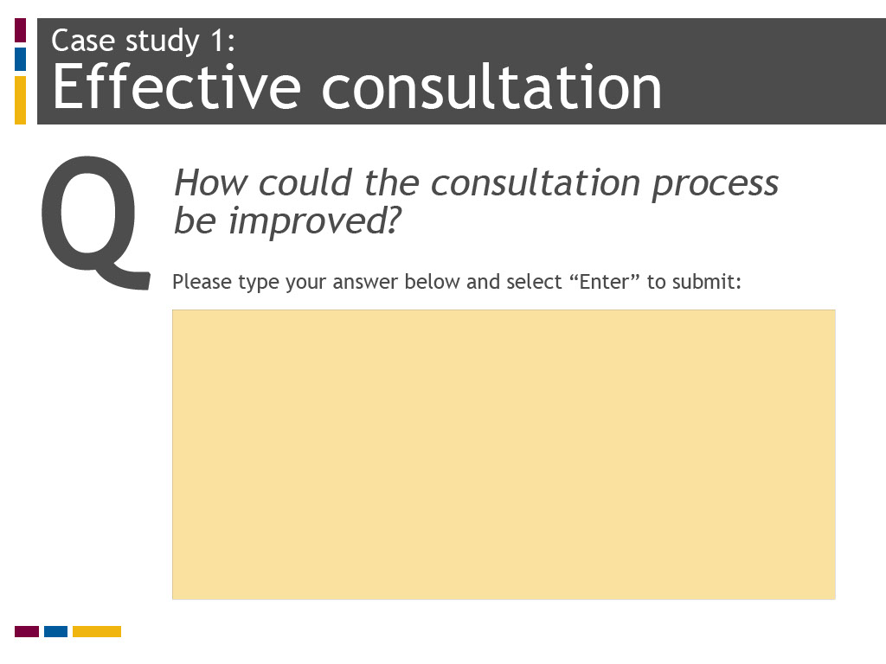
Slide notes
Text Captions

Case study 1:
Effective consultation

How could the consultation process be improved?

Slide 24 - Case study 1 Answer
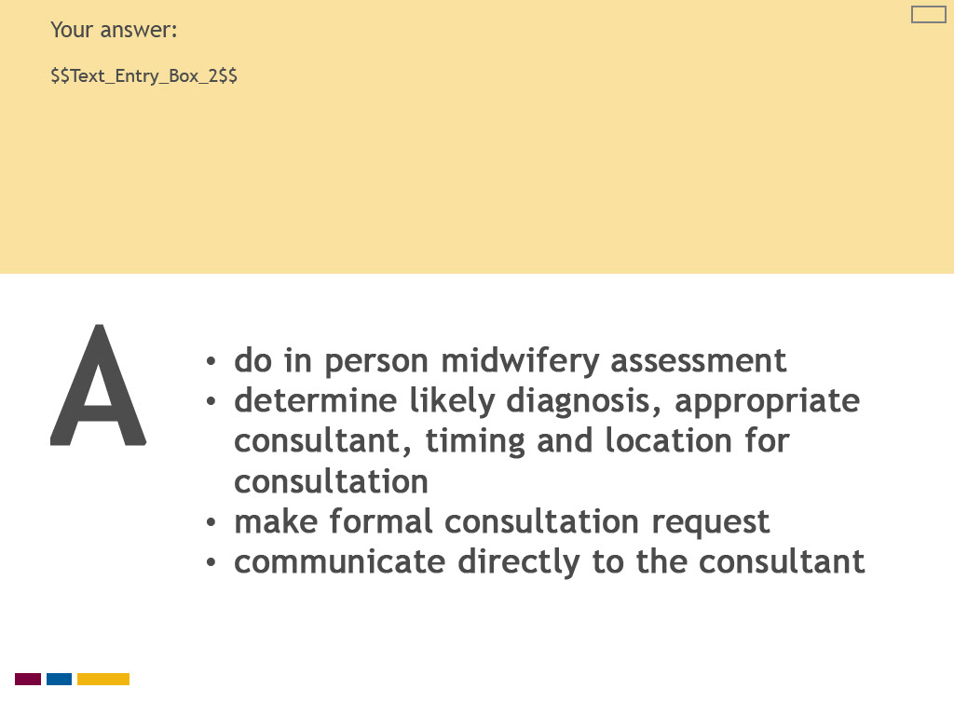
Slide notes
Text Captions

A

Your answer:

do in person midwifery assessment
determine likely diagnosis, appropriate consultant, timing and location for consultation
make formal consultation request
communicate directly to the consultant

Slide 25 - Why is the consultation ineffective?
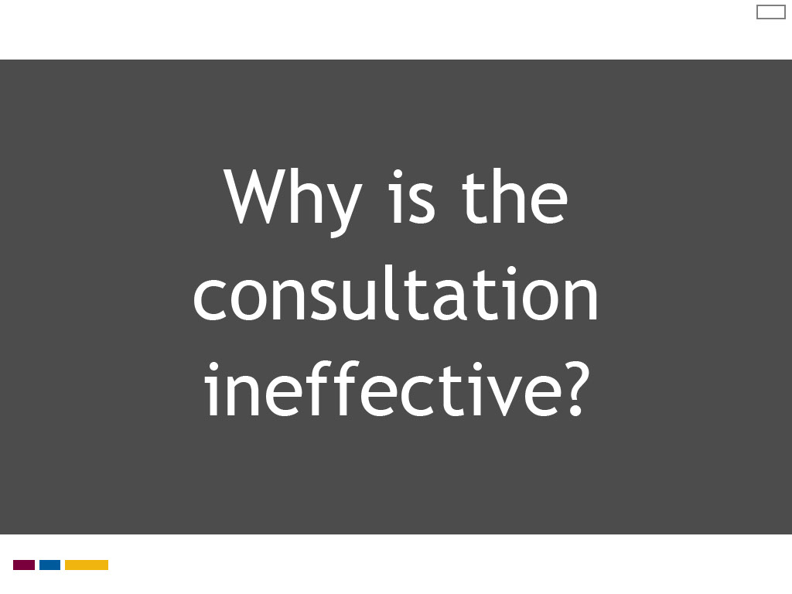
Slide notes
One of the first things that jumps out in this case is that the midwife did not do a full assessment of the client’s condition prior to consultation.
A primary care provider is expected to do a full assessment within their scope of practice to make a clinical diagnosis and determine the need for consultation.
The midwife did not communicate directly with the consultant, verbally or in writing.
Sending a client to a hospital emergency department results in a clinical assessment by the ER physician, and not a consultation.
Using other health services to do assessments within the midwifery scope of practice, such as hospital emergency departments,
walk-in clinics or labour floor triage units, is a poor use of health resources.
Midwives may be seen to be deflecting their primary care responsibilities onto others, which may undermine respect for the individual midwife or the midwifery profession.
It is the midwife’s responsibility to determine the need for consultation and make appropriate arrangements.
Text Captions

Why is the consultation ineffective?

Slide 26 - How can the consultation be improved?
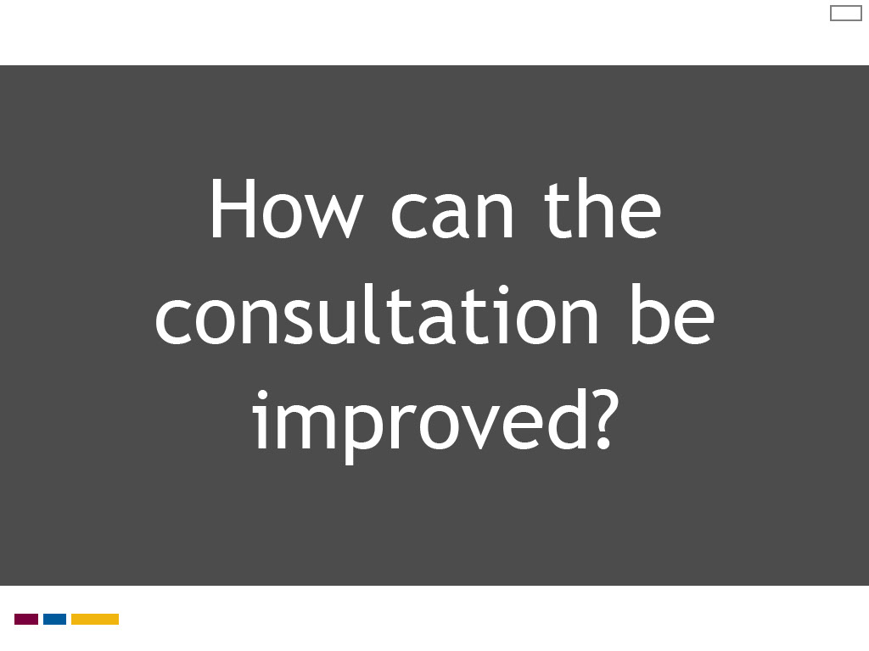
Slide notes
The first step to improve this consultation process is for the midwife to decide if Selma’s symptoms require further assessment.
The midwife needs to determine the level of urgency and the appropriate timing and location for this assessment.
If the midwife suspects preterm labour, for example, it would be suitable to do an immediate assessment at the hospital triage unit given potential morbidities for a 28 week newborn.
If a less acute, non-obstetric cause is suspected, such as indigestion, the midwife may plan to see Selma at the clinic the following day if her symptoms have not resolved.
If an immediate assessment is not done, it would be appropriate to ensure Selma understands when to call back if her symptoms worsen or change.
If the midwife recommends consultation following the in person assessment, they would be expected to follow the process outlined in the college standard,
including making an explicit verbal or written request and arranging an in person consultation by the consultant.
The midwife would also ensure the outcomes of the consultation are clearly understood and documented, and a plan of care is in place.
Text Captions

How can the consultation be improved?

Slide 27 - Interprofessional collaboration in action
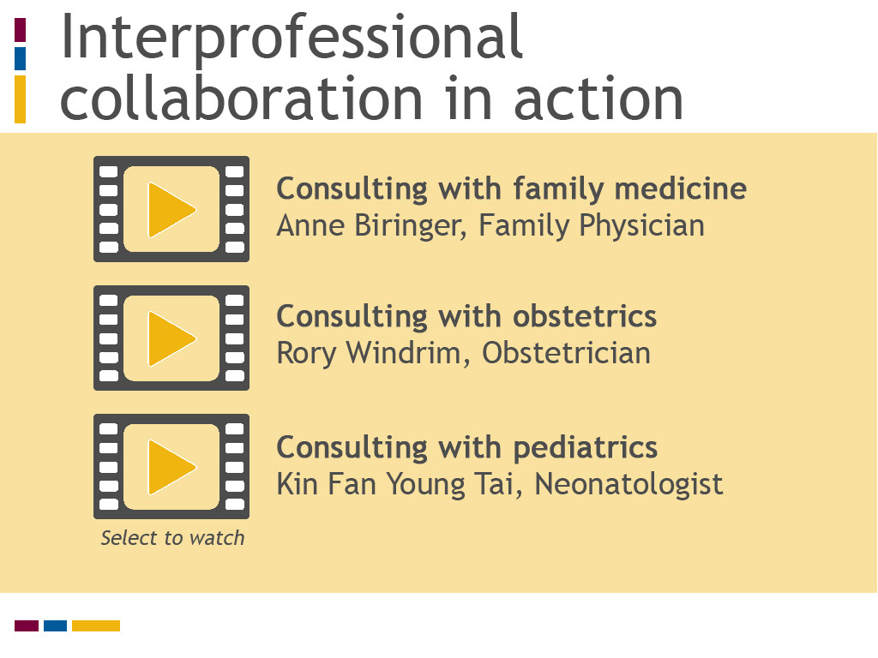
Slide notes
You will now have the opportunity to learn what these three health professionals want to share with you about effective consultation.
As you view or listen to these videos, reflect on the following questions:
What tips does each speaker offer to make consultation more effective? Do they give particular advice about consultation for midwives or midwifery students?
Text Captions

Interprofessional collaboration in action

Select to watch

Consulting with family medicine
Anne Biringer, Family Physician

Consulting with obstetrics
Rory Windrim, Obstetrician

Consulting with pediatrics
Kin Fan Young Tai, Neonatologist

Slide 28 - Key Messages
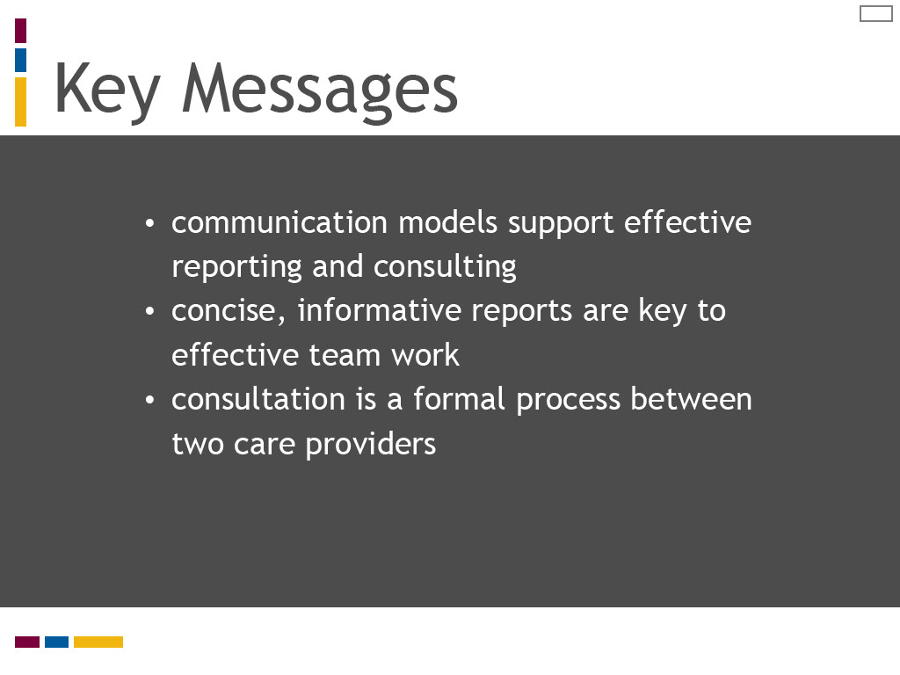
Slide notes
Here are the key messages for this lesson:
Standardized communication models are useful clinical practice tools for reporting and consultation
Concise and informative reports are key to effective team work
Consultation is a formal process between two care providers
Now take the opportunity to test your knowledge from this lesson.
Text Captions

Key Messages

- communication models support effective reporting and consulting
- concise, informative reports are key to effective team work
- consultation is a formal process between two care providers

Slide 29 - Test your knowledge 1
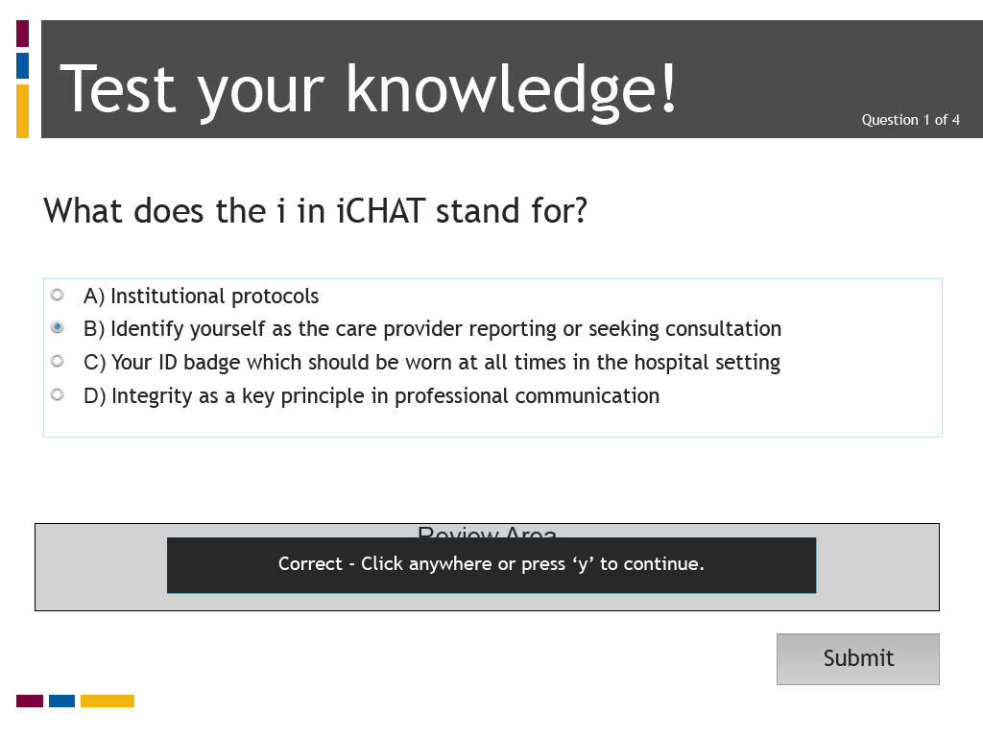
Slide notes
Text Captions

Test your knowledge!

What does the i in iCHAT stand for

A) Institutional protocols

B) Identify yourself as the care provider reporting or seeking consultation

C) Your ID badge which should be worn at all times in the hospital setting

D) Integrity as a key principle in professional communication

Question 1 of 4

The correct answer is B) Identify yourself as the care provider reporting or seeking consultation

Slide 30 - Test your knowledge 1
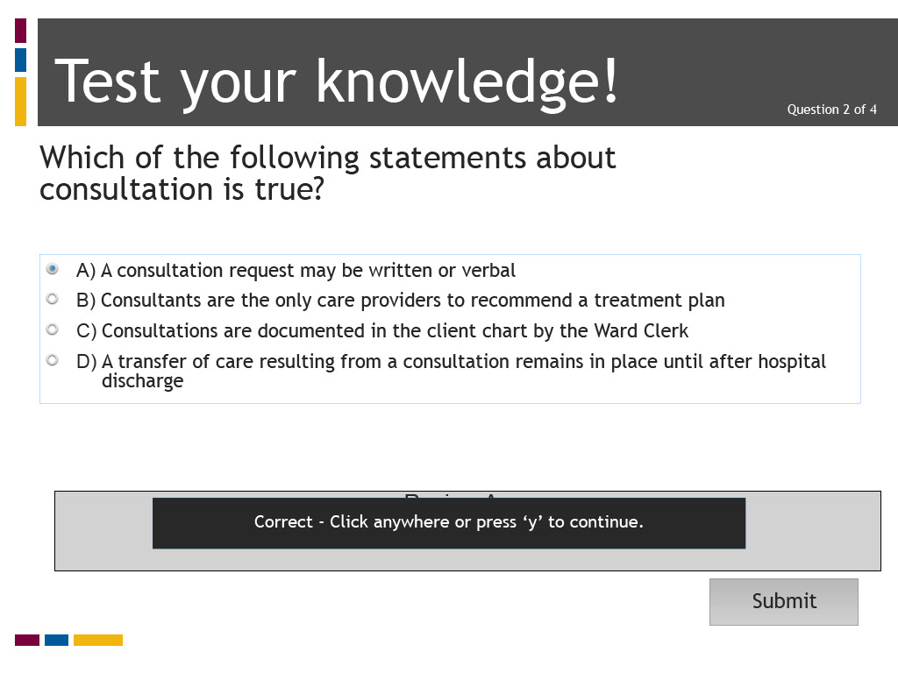
Slide notes
Text Captions

Test your knowledge!

Which of the following statements about consultation is true?

A) A consultation request may be written or verbal

B) Consultants are the only care providers to recommend a treatment plan

C) Consultations are documented in the client chart by the Ward Clerk

D) A transfer of care resulting from a consultation remains in place until after hospital discharge

Question 2 of 4

The correct answer is A) A consultation request may be written or verbal

Slide 31 - Test your knowledge 1
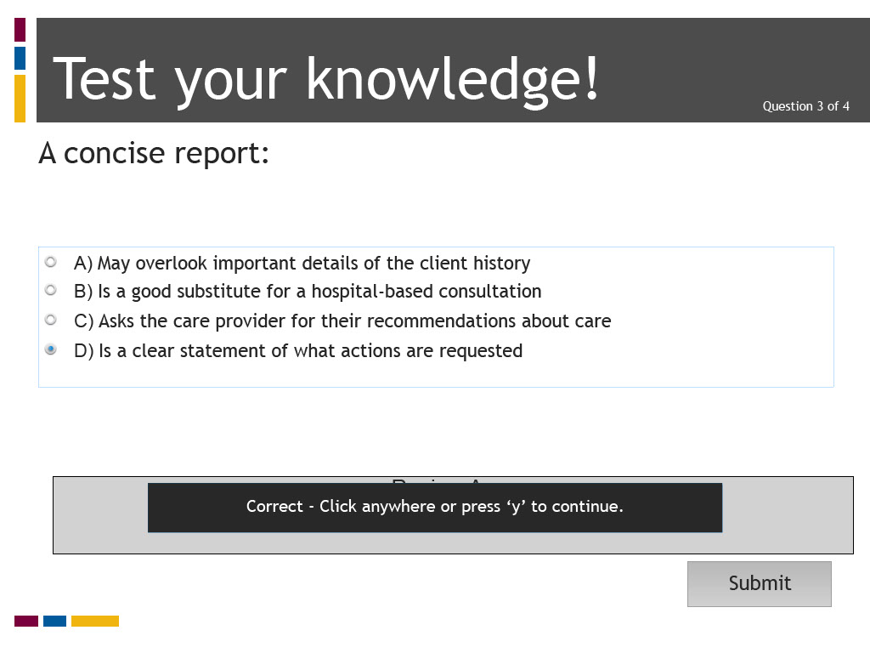
Slide notes
Text Captions

Test your knowledge!

A concise report:

A) May overlook important details of the client history

B) Is a good substitute for a hospital-based consultation

C) Asks the care provider for their recommendations about care

D) Is a clear statement of what actions are requested

Question 3 of 4

The correct answer is D) Is a clear statement of what actions are requested.

Slide 32 - Test your knowledge 1
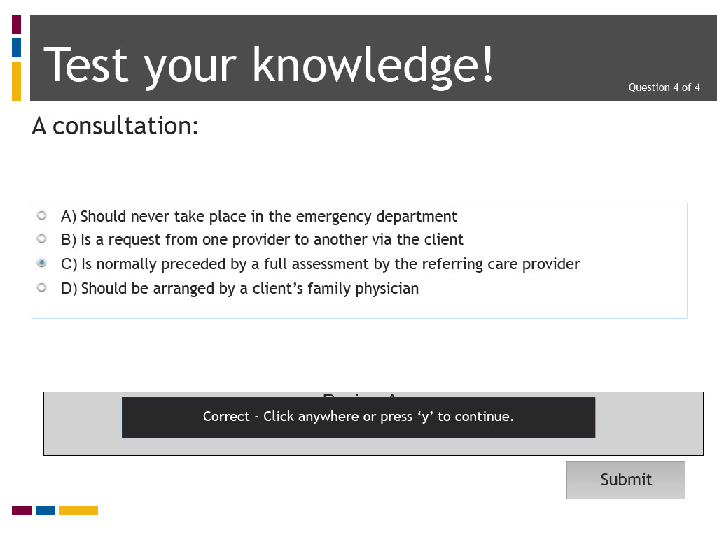
Slide notes
Text Captions

Test your knowledge!

A consultation:

A) Should never take place in the emergency department

B) Is a request from one provider to another via the client

C) Is normally preceded by a full assessment by the referring care provider

D) Should be arranged by a client’s family physician

Question 4 of 4

The correct answer is C) Is normally preceded by a full assessment by the referring care provider

Slide 33 - Quiz Results
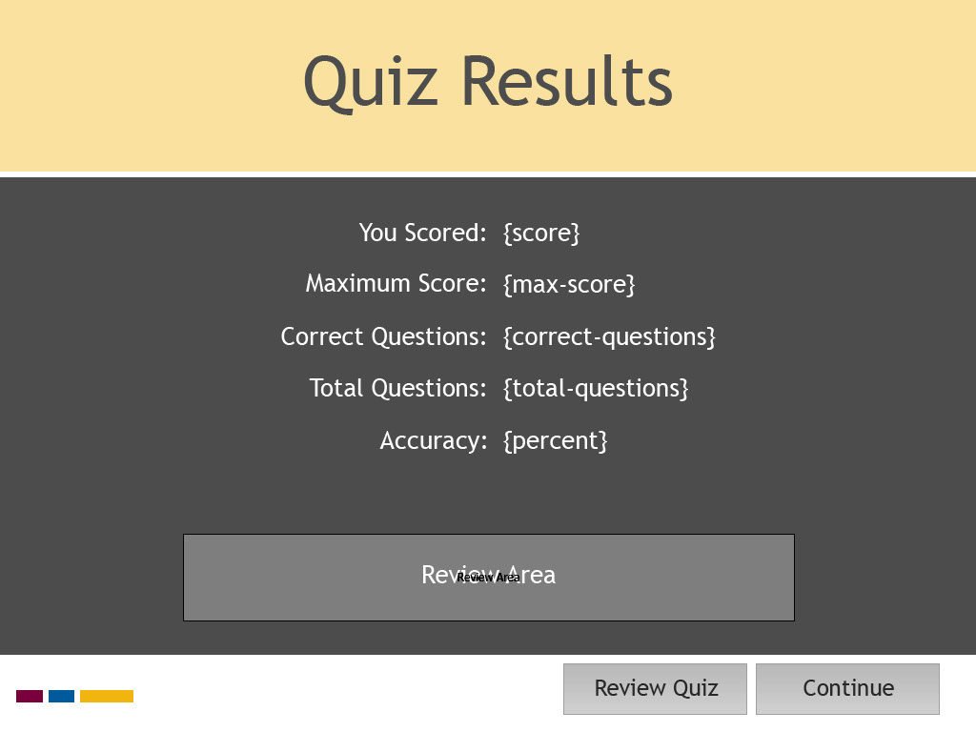
Slide notes
Text Captions

Quiz Results

Slide 34 - References
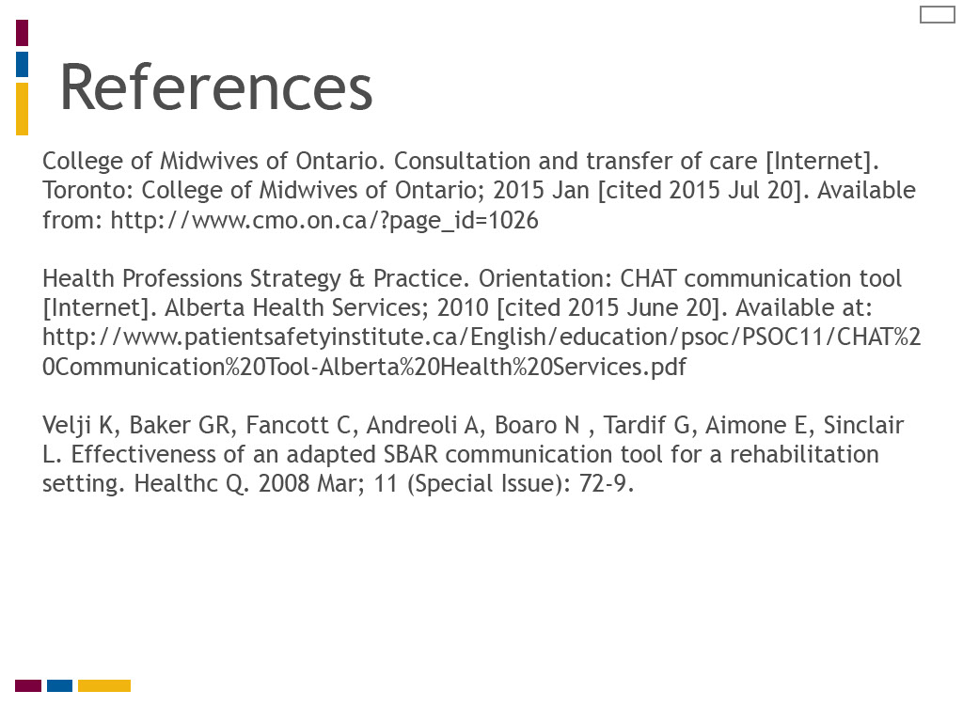
Slide notes
Text Captions

References

College of Midwives of Ontario. Consultation and transfer of care [Internet]. Toronto: College of Midwives of Ontario; 2015 Jan [cited 2015 Jul 20].
Health Professions Strategy & Practice. Orientation: CHAT communication tool [Internet]. Alberta Health Services; 2010 [cited 2015 June 20].
Velji K, Baker GR, Fancott C, Andreoli A, Boaro N , Tardif G, Aimone E, Sinclair L. Effectiveness of an adapted SBAR communication tool for a rehabilitation setting. Healthc Q. 2008 Mar; 11 (Special Issue): 72-9.

Slide 35 - Credits
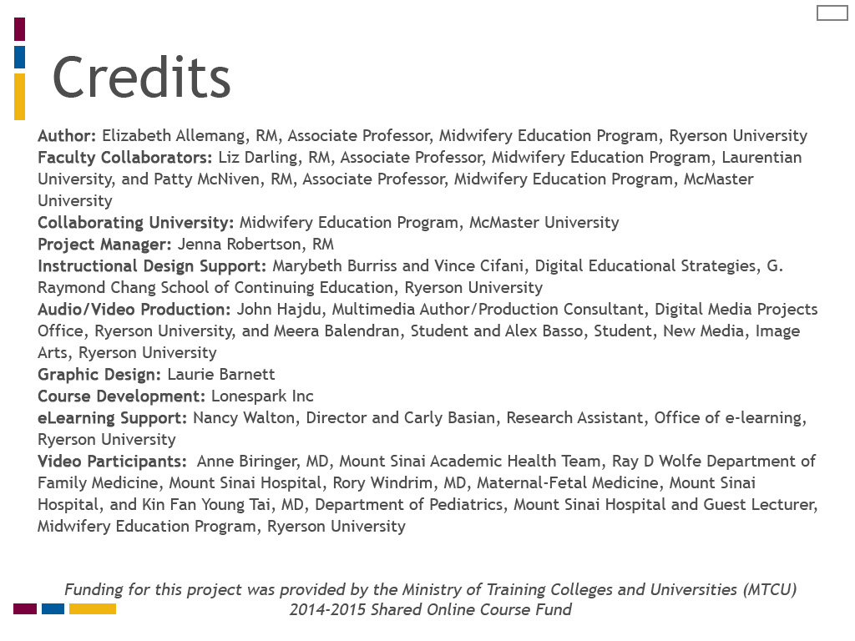
Slide notes
Text Captions

Credits

Author: Elizabeth Allemang, RM, Associate Professor, Midwifery Education Program, Ryerson University
Faculty Collaborators: Liz Darling, RM, Associate Professor, Midwifery Education Program, Laurentian University, and Patty McNiven, RM, Associate Professor, Midwifery Education Program, McMaster University
Collaborating University: Midwifery Education Program, McMaster University
Project Manager: Jenna Robertson, RM
Instructional Design Support: Marybeth Burriss and Vince Cifani, Digital Educational Strategies, G. Raymond Chang School of Continuing Education, Ryerson University
Audio/Video Production: John Hajdu, Multimedia Author/Production Consultant, Digital Media Projects Office, Ryerson University, and Meera Balendran, Student and Alex Basso, Student, New Media, Image Arts, Ryerson University
Graphic Design: Laurie Barnett
Course Development: Lonespark Inc
eLearning Support: Nancy Walton, Director and Carly Basian, Research Assistant, Office of e-learning, Ryerson University
Video Participants: Anne Biringer, MD, Mount Sinai Academic Health Team, Ray D Wolfe Department of Family Medicine, Mount Sinai Hospital, Rory Windrim, MD, Maternal-Fetal Medicine, Mount Sinai Hospital, and Kin Fan Young Tai, MD, Department of Pediatrics, Mount Sinai Hospital and Guest Lecturer, Midwifery Education Program, Ryerson University

Funding for this project was provided by the Ministry of Training Colleges and Universities (MTCU) 2014-2015 Shared Online Course Fund

Slide 36 - Certificate of Completion
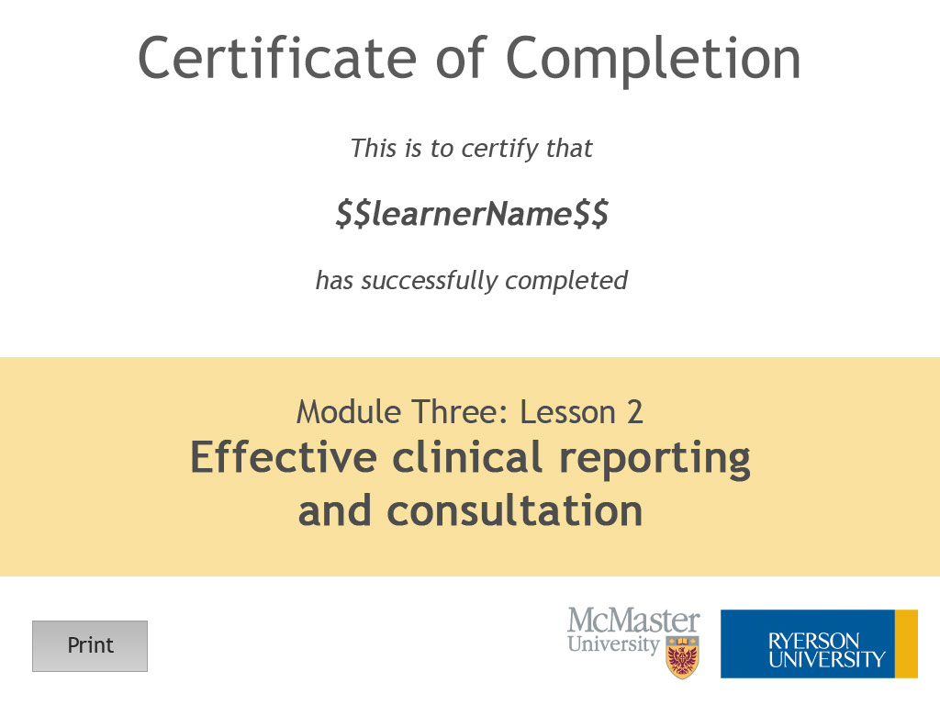
Slide notes
Text Captions

Module Three: Lesson 2
Effective clinical reporting
and consultation

