

Working Papers: Publish With Us

About the series

The Working Papers Series is produced by the Global Migration Institute at Toronto Metropolitan University.

Working Papers present scholarly research of all disciplines on issues related to migration and integration. The purpose is to stimulate discussion and collect feedback. The views expressed by the author(s) do not necessarily reflect those of the Institute.

The Working Paper Series is edited by Richa Shivakoti, Research Area Lead, Migration Governance, Global Migration Institute.

Please contact us with any questions about publications: global.migration@torontomu.ca

Details

There is no requirement for formal affiliation with the Global Migration Institute, Toronto Metropolitan University, or any academic institution in order to submit a Working Paper for publication. We will consider submissions from students, faculty, and community members for the Working Paper series.

The suitability of your Working Paper for publication will ultimately depend on the content of your submission and is up to the discretion of the Global Migration Institute editors and the independent reviewers.

Information about plagiarism and self-plagiarism can be found in 'Appendix A' of Toronto Metropolitan University’s Academic Integrity policy.

The Global Migration Institute has an open access policy, meaning that our publications are freely available to the public. Publishing with the Global Migration Institute is an excellent outlet for sharing your work with a larger audience to achieve a bigger impact for your research or commentary. The review process also offers a valuable opportunity to enhance the quality and clarity of your writing and further develop your ideas.

How to use this template

This template is designed to help contributors format their Working Paper for submission to the Global Migration Institute's Working Papers Series. To use it, replace the placeholder text in each section with your own content — including your title, author information, abstract, and the body of your paper — while keeping the existing headings, spacing, and formatting intact. Following the template ensures your submission is consistent with the series' style and makes the review process smoother for both you and our editorial team.

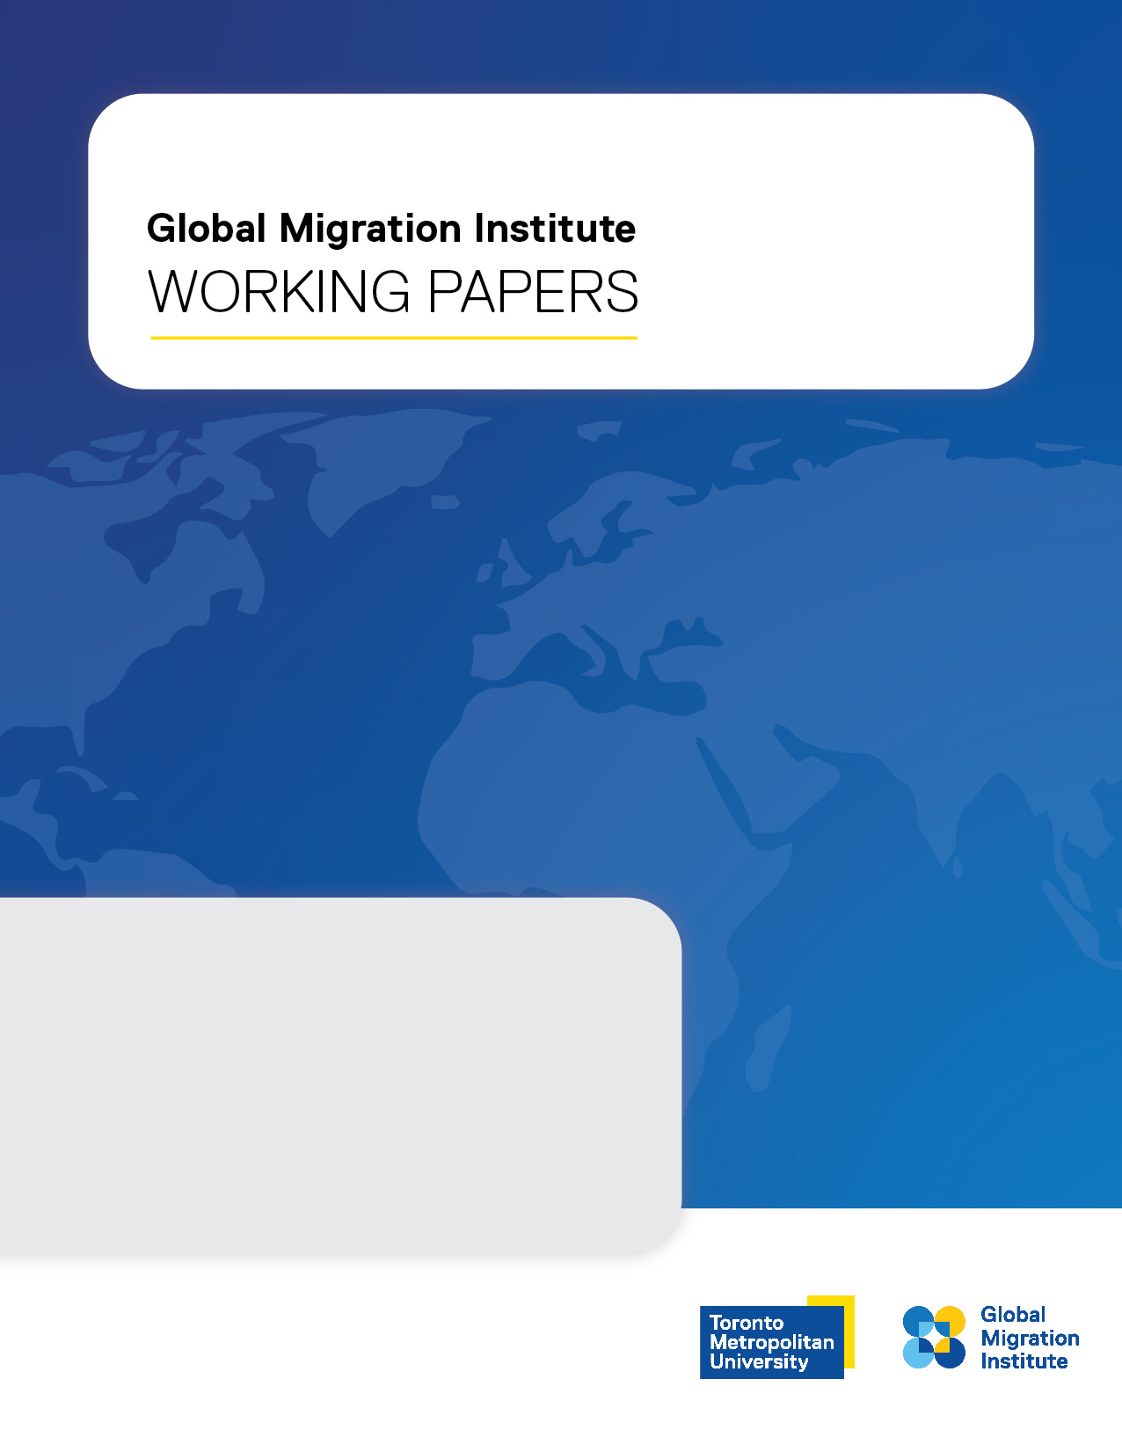
Working Paper No. 25/16
December 2025

INSERT TITLE

INSERT NAME

Working Paper
No. YYYY/##

Paper title
Author 1 full name
Institution

Author 2 full name
Institution

Series Editor: Richa Shivakoti

The Working Papers Series is produced by the Global Migration Institute at Toronto Metropolitan University.
Working Papers present scholarly research of all disciplines on issues related to immigration and settlement. The purpose is to stimulate discussion and collect feedback. The views expressed by the author(s) do not necessarily reflect those of the GMI.
For further information, visit https://www.torontomu.ca/global-migration-institute/

ISSN: 1929-9915

Creative Commons Attribution-Noncommercial-No Derivative Works 2.5
Canada License



Abstract

Abstract text

Table of Contents

Abstract i
Font Style and Size 1
Headings 1
Spacing 1
Footer 1
Margins 1
Quotations 1
References 1

Font Style and Size

Document – Arial, Size 11
Footnote – Arial, Size 10
Page Number – Arial, Size 11
Tables & Charts – Arial, Size variable

Headings

Heading Level 1 – Bold, Arial, Size 11
Heading Level 2 – Bold, Italic, Arial, Size 11
Heading Level 3 – Indented, Bold, Italic, Arial, Size 11
Heading Level 4 – Indented, Italic, Arial, Size 11

Spacing

Single spacing throughout
Insert 2 blank lines (space) before new headings
Insert 1 blank line (space) after headings
Insert 1 blank line (space) after bulleted lists

Footer

Page number – center alignment

Margins

2.54 cm margins
Align the body of the paper in full justification

Quotations

Indent quotes of more than 40 words and bullet points

References

Hyperlinks removed/deactivated
Hanging indent
Left justified
APA guidelines

